**Day 3, Monday April 29: Caesarea**

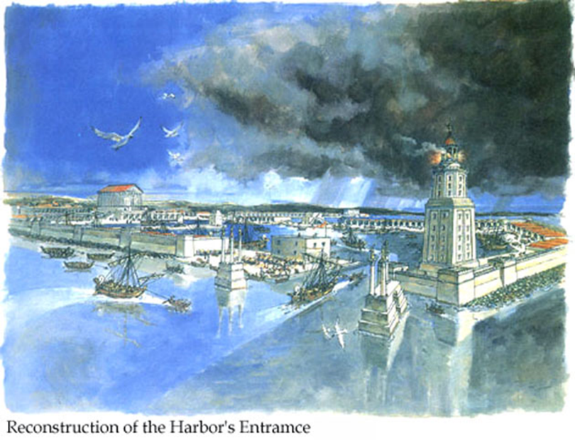Caesarea began as a small anchorage, built by the Phoenicians in the middle of the third century B.C., calling it Strato’s Tower. The Roman conquest of Jerusalem under General Pompey in 64 B.C. separated the coastal towns from Judean control and brought the Roman procurators as the new masters.

When Caesar Augustus made Herod the Great king of Judea and gave him the coastal region as well, he rebuilt Strato’s Tower and renamed it Caesarea in honor of Caesar Augustus. He turned it into a showcase city with an artificial harbor. From 6 A.D, it served as the seat of the Procurators of Judea, essentially the Roman capital of Palestine. Herod Agrippa I died at Caesarea, being “eaten with worms.” Acts 12:19-23 says that he had delivered a great speech and the people said, “It is the voice of a god, and not a man.” Because he did not give God the glory, he was struck down by the angel of the Lord.

Most of the ruins visible today are from the Roman and Crusader periods.

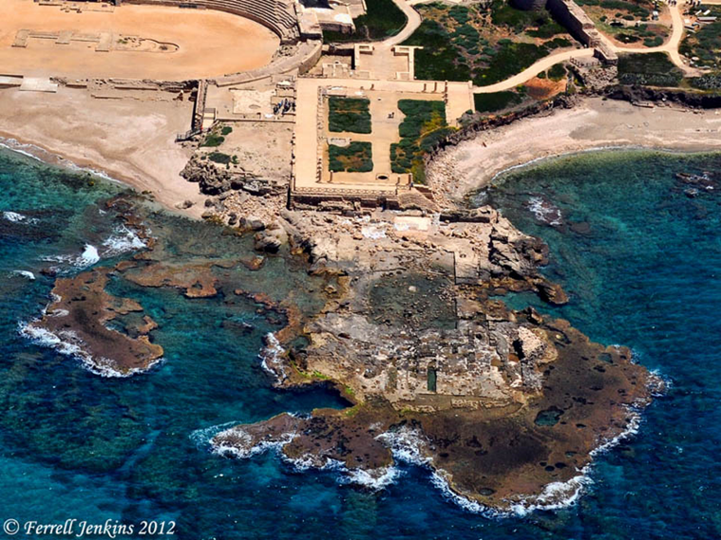 When making his final Journey to Jerusalem, Paul stopped off for a few days with Luke and others staying at the home of Phillip. Agabus prophesied that if Paul continued on to Jerusalem, he would be imprisoned. Paul refused the advice not to go on (Acts 21:10-13). After being arrested in Jerusalem, his life was endangered by 40 men pledged to kill him. (Acts 23:31-35) *31 So the soldiers, carrying out their orders, took Paul with them during the night and brought him as far as Antipatris. 32 The next day they let the cavalry go on with him, while they returned to the barracks. 33 When the cavalry arrived in Caesarea, they delivered the letter to the governor and handed Paul over to him. 34 The governor read the letter and asked what province he was from. Learning that he was from Cilicia, 35 he said, "I will hear your case when your accusers get here." Then he ordered that Paul be kept under guard in Herod's palace.* The square in the upper middle of the picture is the outline of Herod’s palace as well as the square in the rocks partially in the water. Notice the part of the square has been eroded by the sea. I like to look in that area to see what the sea may have uncovered from the foundation of the palace.

The dynasty of the Herodians are key figures in the New Testaments and in the archaeology of the first century.

Paul defended himself three times in Caesarea; first before Felix, then before Ananias the high priest, and lastly before Festus, the governor who succeeded Felix. In his final defense, Paul exercised his right as a Roman citizen to appeal to Caesar, and was sent to Rome for his final trial and execution. Paul’s speech before King Agrippa was delivered in the amphitheater, where we will stop today.

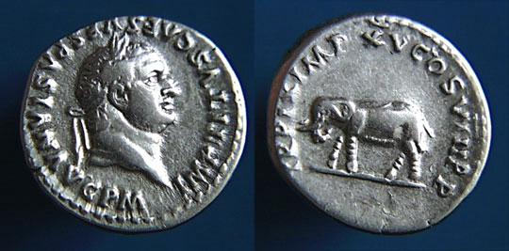 In 66 A.D., the Jews of Caesarea revolted against Rome. General Vespasian had his headquarters here and was ultimately declared Caesar in this city. He was the one who dealt with the riots that followed the revolt. Twenty thousand Jews died at the hands of the Roman troops and members of the large Syrian community residing here. These troubles touched off the Great Jewish War, which culminated in the destruction of Jerusalem in 70 A.D. by Vespasian’s son Titus, shown here. After the conquest of Jerusalem, Titus returned to Caesarea and held “games” in the city in which 2,500 Jewish prisoners died.

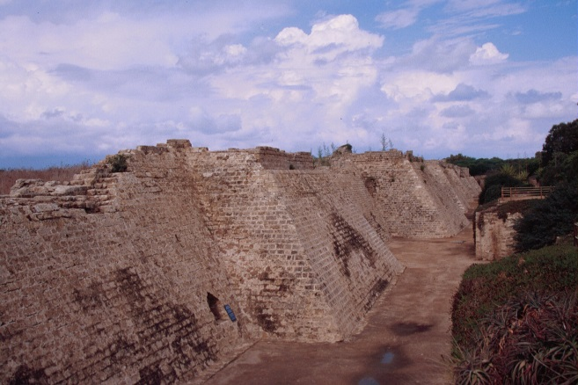 Caesarea developed a strong Christian presence early in the Christian era, even before Christianity was legalized. From here, missionaries were sent to evangelize the world.

A major Christian Council was held here in 195 A.D.

A significant Christian school of theology was founded here by Origen. Eusebius, one of the first great Christian historians, was bishop in Caesarea from 313 to 340 A.D.

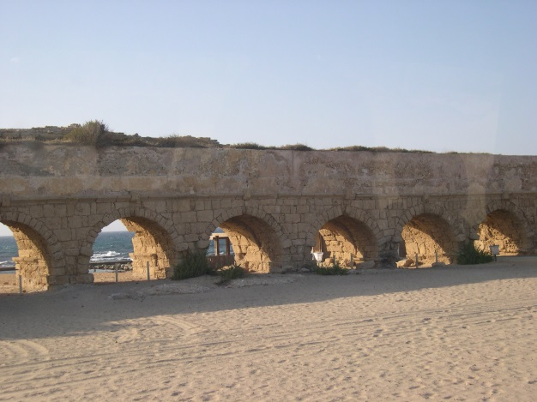 Many battles have been fought on this ground. In 548 the Jews and Samaritans assaulted the Christians. The Muslim conquests of this area first took place in 638. It remained under Islamic control until the crusaders recaptured the city in 1102. The population during the Crusader period was about 4,800 people. It went back under Islamic control when Saladin retook it in 1189, but the crusaders recaptured it again two years later. King Louis IV of France was the builder of these Crusader fortifications in 1251. The moat is a dry moat but even in its current broken condition, the ruins are still impressive. The effort to retain Christian control of the city ended when the sultan Baybars captured it in 1265, with the Crusaders retreating by sea to Acre. The Moslems systematically destroyed it to keep it from falling again to the Crusaders. The ruins, both Crusader and Roman, were gradually covered by drifting sand, and have only been uncovered in the last 25 years. Since New Testament times the sea level has variously been at least three feet lower and two feet higher.

The entire medieval history was summarized by George Adam Smith: “As long as the land was held by men with interests in the west, the town triumphed over the unsuitableness of its site. But when Palestine passed into the hands of an eastern people with no maritime ambitions, it dwindled and was finally destroyed by them.”

In 1961 a stone was unearthed here with the name Pontius Pilate inscribed on it. That discovery provided the first physical confirmation, outside the Bible and the coins that he minted, that such a man had ever existed.

Here are a few of the biblical references to the city. It was the home base of Cornelius (Acts 10:24) as well as the home of Phillip the Evangelist, his wife, and four daughters (Acts 21:8). Herod Agrippa I, who killed James and imprisoned Peter, lived here (Acts 12:19). He died at a celebration here in 44 A.D. Paul was taken here for protection from the Jewish plot to kill him (Acts 23:23). He actually spent a two-year imprisonment and trial before Felix in this city. (Acts 25:4) Festus was located here (Acts 25:1). Paul was transported from here to Italy for his final trial (Acts 27:1).

For me, the most important biblical event was the salvation and outpouring of the Holy Spirit upon the Roman Centurion, Cornelius. Cornelius was a man of prayer and concern for the poor. God saw his heart and sent Peter from Joppa, even though Phillip probably lived across town. After Pentecost itself, this was probably the most important event relating to the baptism of the Holy Spirit because it was the first time that any Gentile has received this experience. As a Gentile Pentecostal we are returning to the place where, at least for us, it all began.

The aqueduct that supplied the city with water from the Carmel hills that you see to the north.

For me, the most important biblical event was the outpouring of the Holy Spirit upon the Roman Centurion, Cornelius.

*1 At Caesarea there was a man named Cornelius, a centurion in what was known as the Italian Regiment. 2 He and all his family were devout and God-fearing; he gave generously to those in need and prayed to God regularly. 3 One day at about three in the afternoon he had a vision. He distinctly saw an angel of God, who came to him and said, "Cornelius!" 4 Cornelius stared at him in fear. "What is it, Lord?" he asked. The angel answered, "Your prayers and gifts to the poor have come up as a memorial offering before God. 5 Now send men to Joppa to bring back a man named Simon who is called Peter. 6 He is staying with Simon the tanner, whose house is by the sea." 7 When the angel who spoke to him had gone, Cornelius called two of his servants and a devout soldier who was one of his attendants. 8 He told them everything that had happened and sent them to Joppa.*

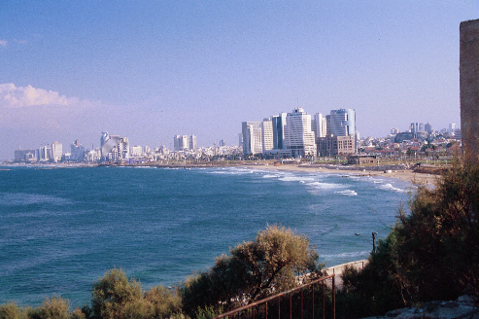

Events almost brought two men together. Peter was visiting areas south of Caesarea. He had seen some great miracles at Lydda and at Joppa as recorded in the previous chapter. (I have been to Lydda several times but have never stopped. Why you ask, did I not stop? Lydda is presently beneath the runway of the Tel Aviv Airport.) Peter ended up at the house of Simon the Tanner in Joppa and had been there for some time.

Cornelius was just doing his duty as a Roman Soldier stationed at the Provincial capitol of Judea, Caesarea. As it turned out, his time among the Jews allowed him to fulfill a desire to know God.

Most every Roman soldier would have sworn allegiance to one of the Roman gods. The Romans were pagans. Cornelius was different. He did not think highly of the Romans gods. When he discovered that the Jews worshipped Jehovah as the one true God, it rang true with him. He left the pagan gods of his youth behind and attached himself to the synagogue. He determined to do everything required by Jehovah and so he became a “God-fearer.”

As such he is an answer to the question of what about the heathen who have never heard. When Cornelius heard about Jehovah, it resonated in his heart because he was trying to serve God according to the understanding that he had. At that point, God took responsibility to get Cornelius all the way home. In Acts 10 we have the account of how God gave clarity to the desire that he had to do right. This is what God does for all those presently among the heathen who want to do right.

In this passage, Cornelius is described as devout and God-fearing. This had a precise meaning which Luke gives us here. Cornelius “*gave generously to the poor and prayed to God regularly*.” Luke specifically mentions two of the three required righteous acts. The Early Church saw Cornelius as displaying all three of the essential acts of righteousness. Luke mentions two acts, but we should clearly infer all three. For example Tertullian’s book on fasting holds him up as someone who fasted.[1]

Certainly Cornelius was a person who had a discipline of prayer. He not only prayed but he did so on a schedule. It was “regular.” In this case, he made it a habit to pray at three o’clock in the afternoon. From other Scriptures we know the meaning of this specific time. For example, we know from Acts 3:1 “*One day Peter and John were going up to the temple at the time of prayer-- at three in the afternoon*,” that this was the hour of prayer for righteous people. Even though the Temple was in Jerusalem, the time of the evening service would have been observed everywhere. It is significant that Cornelius is apparently praying at this time. His schedule of prayer reminds me of the Apostle John who testified in Revelation that “he was in the Spirit on the Lord’s day.” The discipline of prayer was rewarded. In the case of Cornelius, none other than the angel of the Lord appears to him as he prays.

This part of the story should teach us something about the habit of prayer. You can pray anywhere at any time. That should not change the fact that you have a discipline of prayer as well. If you pray at the same time, and in the same place, every day you will find it easier and easier to pray when it is time to pray.

In our text, the angel acknowledges that the specific behavior of Cornelius had come up as a memorial offering before God. People who say that behavior does not matter must have trouble with this verse. We certainly believe in the grace of God and I do not believe that we “earn” salvation. However this verse teaches us that God honors good deeds as well. In particular, the angel assures Cornelius that his actions really mattered to God. The angel gave Cornelius instruction on how to take the next step with God.

Some have tried to argue that the role of a soldier is incompatible with the life of a Christian. I would note that Jesus commended the Roman Centurion at Capernaum for having great faith and honored this man as the first Gentile to receive the Baptism of the Holy Spirit. He was not required to abandon his military profession upon his profession of faith. Neither John the Baptist nor Jesus asked soldiers to leave their profession but to act honorably by avoiding extortion and by being content with their wages. In particular, there are books out now that try to make the case that the early church was pacifist. They did object to the soldiers swearing loyalty to the Roman deity. That was the basis of the early church objection, not the life of military service itself. Indeed, by the third century, whole Legions of the Roman army had become Christian.

*9 About noon the following day as they were on their journey and approaching the city, Peter went up on the roof to pray. 10 He became hungry and wanted something to eat, and while the meal was being prepared, he fell into a trance. 11 He saw heaven opened and something like a large sheet being let down to earth by its four corners. 12 It contained all kinds of four-footed animals, as well as reptiles of the earth and birds of the air. 13 Then a voice told him, "Get up, Peter. Kill and eat." 14 "Surely not, Lord!" Peter replied. "I have never eaten anything impure or unclean." 15 The voice spoke to him a second time, "Do not call anything impure that God has made clean." 16 This happened three times, and immediately the sheet was taken back to heaven*.

Even though Cornelius was well prepared to receive Jesus, God had one more obstacle to get over. The Apostle Peter had some ideas about Kosher food that didn’t square with what God had in mind. It would take some convincing to get past his built in prejudice about how things should go.

We may find ourselves in the same position. The harvest might be prepared, but we may be the ones standing in the way.

There is an irony here. Both Peter and Cornelius were doing what they felt to be right and in both cases Jesus used that to direct them into his will. Even though Peter was mistaken about what God wanted, at least he could say that he had never eaten anything impure or unclean. He had religiously followed what he knew of what God expected.

Three times, God tells him to do what his religion had told him not to do. God had to show to him that God was greater than the law. If God had made something clean, Peter should not call it unclean. Peter will soon realize this is **not about eating reptiles, but accepting Gentiles into the kingdom of God.**

There is a second irony in the necessity of God to redirect Peter with this vision. This was a subject upon which Jesus had taught earlier. It is contained in Mark’s Gospel which by most accounts is the Gospel most shaped by Peter himself.[2] That is, Mark becomes the scribe for Peter in this Gospel. Given this history in Acts 10, you can understand why Peter would have given so much emphasis to the original teaching in Mark 7:1-23. I am thinking here particularly of verse 8 where Jesus said, “*You have let go of the commands of God and are holding on to the traditions of men."* Also verse 15, “*Nothing outside a man can make him 'unclean' by going into him. Rather, it is what comes out of a man that makes him 'unclean.'"* Mark’s Gospel recorded the conclusion of the matter like this from verse 19 “*(In saying this, Jesus declared all foods "clean.")*

Peter had listened to Jesus teach on this subject, the same subject as the vision of the sheet. However, it took the experience of the vision for Peter to accept emotionally what Jesus had taught in Mark 7. Even so, Peter was slow on this subject. Peter’s slowness is dealt with in Galatians and is also the subject of the controversy in Acts 15.[3] But even then, the message was not so much about the food, but about people whom Peter would also have called unclean. The food became a metaphor for the people. If Peter could accept their food, maybe he could accept the people themselves. That is what Jesus wanted Peter to do because Jesus was calling Peter to an encounter with Gentiles.

*17 While Peter was wondering about the meaning of the vision, the men sent by Cornelius found out where Simon's house was and stopped at the gate. 18 They called out, asking if Simon who was known as Peter was staying there. 19 While Peter was still thinking about the vision, the Spirit said to him, "Simon, three men are looking for you. 20 So get up and go downstairs. Do not hesitate to go with them, for I have sent them." 21 Peter went down and said to the men, "I'm the one you're looking for. Why have you come?" 22 The men replied, "We have come from Cornelius the centurion. He is a righteous and God-fearing man, who is respected by all the Jewish people. A holy angel told him to have you come to his house so that he could hear what you have to say." 23 Then Peter invited the men into the house to be his guests. The next day Peter started out with them, and some of the brothers from Joppa went along*.

Having seen the vision, Peter was still uncertain about its meaning. At the same time the delegation from Cornelius arrived, the Holy Spirit directed Peter to go with the men. Peter did not have to rely upon the men to determine the will of God. God spoke to him directly.

*24 The following day he arrived in Caesarea. Cornelius was expecting them and had called together his relatives and close friends. 25 As Peter entered the house, Cornelius met him and fell at his feet in reverence. 26 But Peter made him get up. "Stand up," he said, "I am only a man myself."*

It is clear that Cornelius is expecting to meet with God. He has gathered his family and friends together. It is hard to imagine having a great encounter with God that you don’t want to share with your family and friends. Maybe that is one of the signs that something real has happened. We want to share it with those we love.

Cornelius further shows his feelings by bowing down before Peter who rightly rejects such reverence as belonging to the Lord alone.

*27 Talking with him, Peter went inside and found a large gathering of people. 28 He said to them: "You are well aware that it is against our law for a Jew to associate with a Gentile or visit him. But God has shown me that I should not call any man impure or unclean. 29 So when I was sent for, I came without raising any objection. May I ask why you sent for me?" 30 Cornelius answered: "Four days ago I was in my house praying at this hour, at three in the afternoon. Suddenly a man in shining clothes stood before me 31 and said, 'Cornelius, God has heard your prayer and remembered your gifts to the poor. 32 Send to Joppa for Simon who is called Peter. He is a guest in the home of Simon the tanner, who lives by the sea.' 33 So I sent for you immediately, and it was good of you to come. Now we are all here in the presence of God to listen to everything the Lord has commanded you to tell us."*

Peter cannot help but point out how unusual it is for him to be in the house of a Gentile. Although everyone there would have already known this, it is important for Peter to say it. It helped to set the stage that this is an important moment that God is directing. His statement about “clean and impure” is a very positive statement that must have helped them be open to whatever Peter would share next.

For the third time we have a retelling of the story. Once again we are reminded that God values almsgiving and prayer. Cornelius has been well prepared by the Lord to receive this message. In Luke’s telling of this story, he is careful to emphasize what God has said through his messengers, the angels. It was at God’s initiative that the Spirit comes to the Gentiles. If God has sent his angels with this message, then it should be received.

It is hard to image a more receptive audience than what Peter had for this sermon. Cornelius already has a sense for the presence of God. He knew this was a God-ordained moment. He also knew that when Peter spoke, it was a word from the Lord.

*34 Then Peter began to speak: "I now realize how true it is that God does not show favoritism 35 but accepts men from every nation who fear him and do what is right. 36 You know the message God sent to the people of Israel, telling the good news of peace through Jesus Christ, who is Lord of all. 37 You know what has happened throughout Judea, beginning in Galilee after the baptism that John preached—38 how God anointed Jesus of Nazareth with the Holy Spirit and power, and how he went around doing good and healing all who were under the power of the devil, because God was with him. 39 "We are witnesses of everything he did in the country of the Jews and in Jerusalem. They killed him by hanging him on a tree, 40 but God raised him from the dead on the third day and caused him to be seen. 41 He was not seen by all the people, but by witnesses whom God had already chosen-- by us who ate and drank with him after he rose from the dead. 42 He commanded us to preach to the people and to testify that he is the one whom God appointed as judge of the living and the dead. 43 All the prophets testify about him that everyone who believes in him receives forgiveness of sins through his name*."

The message that Peter preached had several important features for that audience but also for the whole of Christian history. It helps us to know what is important in the Christian life and what is of less importance. In verse 34-35 we learn that the kingdom of God is open to everyone, not just Jews. For Luke, this is the central message of this passage. He is showing the transition from a purely Jewish religion to one that is to all the world. The message was sent to Israel, but it was that Jesus is Lord of all, not just the Jews.

*44 While Peter was still speaking these words, the Holy Spirit came on all who heard the message. 45 The circumcised believers who had come with Peter were astonished that the gift of the Holy Spirit had been poured out even on the Gentiles. 46 For they heard them speaking in tongues and praising God. Then Peter said, 47 "Can anyone keep these people from being baptized with water? They have received the Holy Spirit just as we have." 48 So he ordered that they be baptized in the name of Jesus Christ. Then they asked Peter to stay with them for a few days*. (NIV)

No one lays hands upon these Gentiles. In a sovereign way, the Spirit comes upon them. This is another bit of information that shows that God is acting alone in bringing his Spirit upon the Gentiles. There is no human agency involved. Luke lets us know how astonishing this was to the Jews, here called “circumcised believers.”

Verse 46 is one of the key verses relating to Pentecostal theology. The word “for”[4] is clearly a word that connects verses 45 and 46. The Jewish believers know that the Gentiles have been baptized in the Holy Spirit because they have heard them speak in tongues and praise God. It was the key indicator of the baptism of the Spirit.

Roger Stronstad has suggested that it was Luke’s intent in Acts to illustrate the “universality of the vocational gift of the Spirit.”[5] No matter where the Gospel went, among Jews or Gentiles, God poured out the gifts of the Spirit. If we use Acts to suggest some things are normative as evidence of the Baptism of the Holy Spirit, are we not doing exactly what Luke did in Acts? We join Peter in reasoning that we know the Spirit is present because “God, who knows the heart, showed that he accepted them by giving the Holy Spirit to them, just as he did to us.”[6] Conversely, Peter would know that a person had not yet been baptized in the Spirit if it had not happened to these others as it had to Peter. Like Peter, we say, if it happened to the 120, and it happened to those at Cornelius’ house, and it happened to us in the same way, then it must be the same thing.

The sequence of events is also very important. These Gentiles receive the baptism of the Holy Spirit before they are baptized in water. Thus Spirit baptism cannot be the same thing as water baptism nor can they be connected.

**Acts 10**--*At Caesarea there was a man named Cornelius, a centurion in what was known as the Italian Regiment. 2 He and all his family were devout and God-fearing; he gave generously to those in need and prayed to God regularly. 3 One day at about three in the afternoon he had a vision. He distinctly saw an angel of God, who came to him and said, "Cornelius!" 4 Cornelius stared at him in fear. "What is it, Lord?" he asked. The angel answered, "Your prayers and gifts to the poor have come up as a memorial offering before God. 5 Now send men to Joppa to bring back a man named Simon who is called Peter. 6 He is staying with Simon the tanner, whose house is by the sea." 7 When the angel who spoke to him had gone, Cornelius called two of his servants and a devout soldier who was one of his attendants. 8 He told them everything that had happened and sent them to Joppa. 9 About noon the following day as they were on their journey and approaching the city, Peter went up on the roof to pray. 10 He became hungry and wanted something to eat, and while the meal was being prepared, he fell into a trance. 11 He saw heaven opened and something like a large sheet being let down to earth by its four corners. 12 It contained all kinds of four-footed animals, as well as reptiles of the earth and birds of the air. 13 Then a voice told him, "Get up, Peter. Kill and eat." 14 "Surely not, Lord!" Peter replied. "I have never eaten anything impure or unclean." 15 The voice spoke to him a second time, "Do not call anything impure that God has made clean." 16 This happened three times, and immediately the sheet was taken back to heaven. 17 While Peter was wondering about the meaning of the vision, the men sent by Cornelius found out where Simon's house was and stopped at the gate. 18 They called out, asking if Simon who was known as Peter was staying there. 19 While Peter was still thinking about the vision, the Spirit said to him, "Simon, three men are looking for you. 20 So get up and go downstairs. Do not hesitate to go with them, for I have sent them." 21 Peter went down and said to the men, "I'm the one you're looking for. Why have you come?" 22 The men replied, "We have come from Cornelius the centurion. He is a righteous and God-fearing man, who is respected by all the Jewish people. A holy angel told him to have you come to his house so that he could hear what you have to say." 23 Then Peter invited the men into the house to be his guests. The next day Peter started out with them, and some of the brothers from Joppa went along. 24 The following day he arrived in Caesarea. Cornelius was expecting them and had called together his relatives and close friends. 25 As Peter entered the house, Cornelius met him and fell at his feet in reverence. 26 But Peter made him get up. "Stand up," he said, "I am only a man myself." 27 Talking with him, Peter went inside and found a large gathering of people. 28 He said to them: "You are well aware that it is against our law for a Jew to associate with a Gentile or visit him. But God has shown me that I should not call any man impure or unclean. 29 So when I was sent for, I came without raising any objection. May I ask why you sent for me?" 30 Cornelius answered: "Four days ago I was in my house praying at this hour, at three in the afternoon. Suddenly a man in shining clothes stood before me 31 and said, 'Cornelius, God has heard your prayer and remembered your gifts to the poor. 32 Send to Joppa for Simon who is called Peter. He is a guest in the home of Simon the tanner, who lives by the sea.' 33 So I sent for you immediately, and it was good of you to come. Now we are all here in the presence of God to listen to everything the Lord has commanded you to tell us." 34 Then Peter began to speak: "I now realize how true it is that God does not show favoritism 35 but accepts men from every nation who fear him and do what is right. 36 You know the message God sent to the people of Israel, telling the good news of peace through Jesus Christ, who is Lord of all. 37 You know what has happened throughout Judea, beginning in Galilee after the baptism that John preached— 38 how God anointed Jesus of Nazareth with the Holy Spirit and power, and how he went around doing good and healing all who were under the power of the devil, because God was with him. 39 "We are witnesses of everything he did in the country of the Jews and in Jerusalem. They killed him by hanging him on a tree, 40 but God raised him from the dead on the third day and caused him to be seen. 41 He was not seen by all the people, but by witnesses whom God had already chosen — by us who ate and drank with him after he rose from the dead. 42 He commanded us to preach to the people and to testify that he is the one whom God appointed as judge of the living and the dead. 43 All the prophets testify about him that everyone who believes in him receives forgiveness of sins through his name." 44 While Peter was still speaking these words, the Holy Spirit came on all who heard the message. 45 The circumcised believers who had come with Peter were astonished that the gift of the Holy Spirit had been poured out even on the Gentiles. 46 For they heard them speaking in tongues and praising God. Then Peter said, 47 "Can anyone keep these people from being baptized with water? They have received the Holy Spirit just as we have." 48 So he ordered that they be baptized in the name of Jesus Christ. Then they asked Peter to stay with them for a few days.*

**Acts 12:19-23** *Then Herod went from Judea to Caesarea and stayed there a while. 20 He had been quarreling with the people of Tyre and Sidon; they now joined together and sought an audience with him. Having secured the support of Blastus, a trusted personal servant of the king, they asked for peace, because they depended on the king's country for their food supply. 21 On the appointed day Herod, wearing his royal robes, sat on his throne and delivered a public address to the people. 22 They shouted, "This is the voice of a god, not of a man." 23 immediately, because Herod did not give praise to God, an angel of the Lord struck him down, and he was eaten by worms and died.* NIV

**Acts 25-26** *Three days after arriving in the province, Festus went up from Caesarea to Jerusalem, 2 where the chief priests and Jewish leaders appeared before him and presented the charges against Paul. 3 They urgently requested Festus, as a favor to them, to have Paul transferred to Jerusalem, for they were preparing an ambush to kill him along the way. 4 Festus answered, "Paul is being held at Caesarea, and I myself am going there soon. 5 Let some of your leaders come with me and press charges against the man there, if he has done anything wrong."*

*6 After spending eight or ten days with them, he went down to Caesarea, and the next day he convened the court and ordered that Paul be brought before him. 7 When Paul appeared, the Jews who had come down from Jerusalem stood around him, bringing many serious charges against him, which they could not prove. 8 Then Paul made his defense: "I have done nothing wrong against the law of the Jews or against the temple or against Caesar." 9 Festus, wishing to do the Jews a favor, said to Paul, "Are you willing to go up to Jerusalem and stand trial before me there on these charges?" 10 Paul answered: "I am now standing before Caesar's court, where I ought to be tried. I have not done any wrong to the Jews, as you yourself know very well. 11 If, however, I am guilty of doing anything deserving death, I do not refuse to die. But if the charges brought against me by these Jews are not true, no one has the right to hand me over to them. I appeal to Caesar!" 12 After Festus had conferred with his council, he declared: "You have appealed to Caesar. To Caesar you will go!" 13 A few days later King Agrippa and Bernice arrived at Caesarea to pay their respects to Festus. 14 Since they were spending many days there, Festus discussed Paul's case with the king. He said: "There is a man here whom Felix left as a prisoner. 15 When I went to Jerusalem, the chief priests and elders of the Jews brought charges against him and asked that he be condemned. 16 "I told them that it is not the Roman custom to hand over any man before he has faced his accusers and has had an opportunity to defend himself against their charges. 17 When they came here with me, I did not delay the case, but convened the court the next day and ordered the man to be brought in. 18 When his accusers got up to speak, they did not charge him with any of the crimes I had expected. 19 Instead, they had some points of dispute with him about their own religion and about a dead man named Jesus who Paul claimed was alive. 20 I was at a loss how to investigate such matters; so I asked if he would be willing to go to Jerusalem and stand trial there on these charges. 21 When Paul made his appeal to be held over for the Emperor's decision, I ordered him held until I could send him to Caesar." 22 Then Agrippa said to Festus, "I would like to hear this man myself." He replied, "Tomorrow you will hear him." 23 The next day Agrippa and Bernice came with great pomp and entered the audience room with the high ranking officers and the leading men of the city. At the command of Festus, Paul was brought in. 24 Festus said: "King Agrippa, and all who are present with us, you see this man! The whole Jewish community has petitioned me about him in Jerusalem and here in Caesarea, shouting that he ought not to live any longer. 25 I found he had done nothing deserving of death, but because he made his appeal to the Emperor I decided to send him to Rome. 26 But I have nothing definite to write to His Majesty about him. Therefore I have brought him before all of you, and especially before you, King Agrippa, so that as a result of this investigation I may have something to write. 27 For I think it is unreasonable to send on a prisoner without specifying the charges against him." 26 Then Agrippa said to Paul, "You have permission to speak for yourself." So Paul motioned with his hand and began his defense: 2 "King Agrippa, I consider myself fortunate to stand before you today as I make my defense against all the accusations of the Jews, 3 and especially so because you are well acquainted with all the Jewish customs and controversies. Therefore, I beg you to listen to me patiently.*

*4 "The Jews all know the way I have lived ever since I was a child, from the beginning of my life in my own country, and also in Jerusalem. 5 They have known me for a long time and can testify, if they are willing, that according to the strictest sect of our religion, I lived as a Pharisee. 6 And now it is because of my hope in what God has promised our fathers that I am on trial today. 7 This is the promise our twelve tribes are hoping to see fulfilled as they earnestly serve God day and night. O king, it is because of this hope that the Jews are accusing me. 8 Why should any of you consider it incredible that God raises the dead? 9 "I too was convinced that I ought to do all that was possible to oppose the name of Jesus of Nazareth. 10 And that is just what I did in Jerusalem. On the authority of the chief priests I put many of the saints in prison, and when they were put to death, I cast my vote against them. 11 Many a time I went from one synagogue to another to have them punished, and I tried to force them to blaspheme. In my obsession against them, I even went to foreign cities to persecute them.12 "On one of these journeys I was going to Damascus with the authority and commission of the chief priests. 13 About noon, O king, as I was on the road, I saw a light from heaven, brighter than the sun, blazing around me and my companions. 14 We all fell to the ground, and I heard a voice saying to me in Aramaic, 'Saul, Saul, why do you persecute me? It is hard for you to kick against the goads.' 15 "Then I asked, 'Who are you, Lord?' "'I am Jesus, whom you are persecuting,' the Lord replied. 16 'Now get up and stand on your feet. I have appeared to you to appoint you as a servant and as a witness of what you have seen of me and what I will show you. 17 I will rescue you from your own people and from the Gentiles. I am sending you to them 18 to open their eyes and turn them from darkness to light, and from the power of Satan to God, so that they may receive forgiveness of sins and a place among those who are sanctified by faith in me.' 19 "So then, King Agrippa, I was not disobedient to the vision from heaven. 20 First to those in Damascus, then to those in Jerusalem and in all Judea, and to the Gentiles also, I preached that they should repent and turn to God and prove their repentance by their deeds. 21 That is why the Jews seized me in the temple courts and tried to kill me. 22 But I have had God's help to this very day, and so I stand here and testify to small and great alike. I am saying nothing beyond what the prophets and Moses said would happen— 23 that the Christ would suffer and, as the first to rise from the dead, would proclaim light to his own people and to the Gentiles." 24 At this point Festus interrupted Paul's defense. "You are out of your mind, Paul!" he shouted. "Your great learning is driving you insane." 25 "I am not insane, most excellent Festus," Paul replied. "What I am saying is true and reasonable. 26 The king is familiar with these things, and I can speak freely to him. I am convinced that none of this has escaped his notice, because it was not done in a corner. 27 King Agrippa, do you believe the prophets? I know you do." 28 Then Agrippa said to Paul, "Do you think that in such a short time you can persuade me to be a Christian?" 29 Paul replied, "Short time or long — I pray God that not only you but all who are listening to me today may become what I am, except for these chains." 30 The king rose, and with him the governor and Bernice and those sitting with them. 31 They left the room, and while talking with one another, they said, "This man is not doing anything that deserves death or imprisonment." 32 Agrippa said to Festus, "This man could have been set free if he had not appealed to Caesar."*

1. “Finally, granting that upon the centurion Cornelius, even before baptism, the honorable gift of the Holy Spirit, together with the gift of prophecy besides, had hastened to descend, we see that his fasts had been heard.” Tertullian, “On Fasting”, Ante-Nicene Fathers, Alexander Roberts, D.D., and James Donaldson, LL.D., eds., (Massachusetts: Hendrickson), Vol.4, pg. 107.
2. The general outline was probably Peter’s, but Peter died in 67 AD, and would not have seen the final Gospel bearing Mark’s name. Presumably Mark began to write his Gospel shortly before Peter's death, but completed it thereafter. Most scholars date it 60 - 70 AD. (Clement of Alexandria, Origen, Eusebius, Tertullian, and St. Jerome suggest that it was written before St. Peter's death. Mark died in AD 68. In substance, it was Peter’s Gospel.
3. Gal 2:7-12 “On the contrary, they saw that I had been entrusted with the task of preaching the gospel to the Gentiles, just as Peter had been to the Jews. 8 For God, who was at work in the ministry of Peter as an apostle to the Jews, was also at work in my ministry as an apostle to the Gentiles. 9 James, Peter and John, those reputed to be pillars, gave me and Barnabas the right hand of fellowship when they recognized the grace given to me. They agreed that we should go to the Gentiles, and they to the Jews. 10 All they asked was that we should continue to remember the poor, the very thing I was eager to do. 11 When Peter came to Antioch, I opposed him to his face, because he was clearly in the wrong. 12 Before certain men came from James, he used to eat with the Gentiles. But when they arrived, he began to draw back and separate himself from the Gentiles because he was afraid of those who belonged to the circumcision group.”
4. *gar* (gar); a primary particle; properly, assigning a reason (used in argument, explanation or intensification; often with other particles): KJV-- and, as, because (that), but, even, for, indeed, no doubt, seeing, then, therefore, verily, what, why, yet.
5. Stronstad, Roger The Charismatic Theology of St. Luke, p. 68.
6. Acts 15:8.