**Day 5, Wednesday, May 1, 2019**

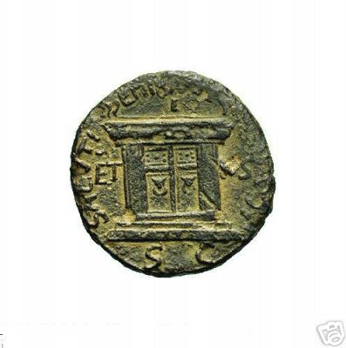**Caesarea Philippi,**

Caesarea Philippi is located near the foot of Mount Hermon and is the main source of the Jordan River. Herod the Great built a marble temple near the spot called Paneas as represented by the coin. The name Banias is an alteration of its original name Paneas.

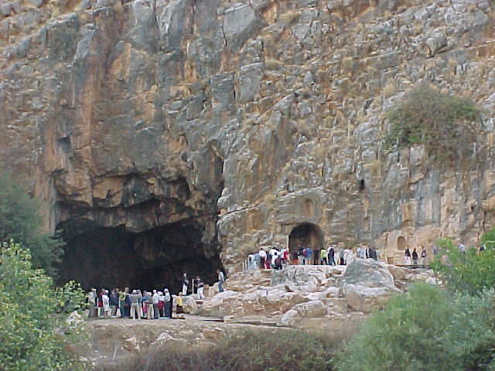The large cave is the mouth from which the Jordan used to flow. It acquired the name, the gate of hell. Given all the paganism, it might be the right name. The Greek fertility-god Pan was worshiped here. Idol images were placed in the carved-out spots seen along the road.

Phillip the tetrarch (Herod Phillip) enlarged the town and changed its name to Caesarea Philippi, in honor of himself and Tiberius Caesar. It was the capital of the area controlled by Phillip.

Here Jesus and his disciples held a very important conversation recorded in Matthew 16. Jesus asked them who people said he was. No doubt it was in full view of the temple of Pan, and the temple for the worship of Cesar, that Peter declared, “Thou art the Christ, the Son of the living God.”

Agrippa II further embellished the town and changed its name to Neronias to honor Emperor Nero of Rome; but after Nero’s death the name quickly faded.

Titus, the Roman conqueror of Jerusalem in 70 A.D., staged gladiator shows here, pitting Jewish slaves against wild animals and against each other.

The Crusaders also lived here with a peak population of about 2,625. They used it as a key fortress to guard the main route from Damascus to Tyre at the point where it descended to the Hula Valley. The Crusaders fortified the city and used it for an attacking base against Damascus. Control of the city went back and forth between Crusaders and Moslems for most of the Crusader period. The Mamluks were the last to actually occupy the city.

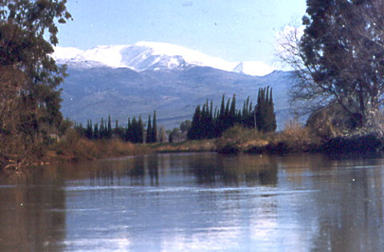The Jordan River has three main sources. The first would be from the Springs of Caesarea Philippi. A little to the West is the second major source at Dan, currently a nature preserve and archaeological site. At Dan the pattern of alternative religion was promoted by Jeroboam as we read in Judges 18 and 1 Kings 12. A Middle Bronze mud-brick gate, the oldest such gate in the world has been here since the time of Abraham in Genesis 14:14.

**Golan Heights and Katzrin**

After Caesarea Philippi we are heading into the Golan Heights and will visit Mt Bental where we can see remains from the Six Day War and look into the troubled land of Syria. The Apostle Paul probably traveled this road on his way to Damascus.

At the end of WWI, the Golan was attached to Syria under the French Mandate. When Israel won its independence in 1948, Syria fortified this area and used it to shell the agricultural settlements in the valleys below. In the six-day war of June 1967 Israel captured the Golan Heights at great cost in lives and equipment. They have vowed never to give it up again. In our visit, we can walk through the many underground bunkers, a maze of tunnels used during the war.

From our hotel we can look across Galilee and see the Golan Heights. This region in Old Testament times was famous for sixty high-walled cities (Deuteronomy 3:4-5; 1 Kings 4:13). In the mountains around this region there are at least one hundred ancient cities, many of them built of basalt.

In the days of Abraham it was occupied by a powerful race of people known as Rephaim (Genesis 14:5). Moses defeated the last of their Kings (Numbers 21:33-35).

In Biblical times the area was celebrated for its cattle, sheep, and oak trees. Ps 68:15-16 “*The mountains of Bashan are majestic mountains; rugged are the mountains of Bashan.* 16 *Why gaze in envy, O rugged mountains, at the mountain where God chooses to reign, where the Lord himself will dwell forever?*”

The following are the notes from a morning and evening message in February 2013 that I gave at Cedar Park. On the very first day in Israel we went to Joppa, the place from which Jonah launched his ill-fated escape. In this passage from Matthew 16 Jesus gives the significance of Jonah as a type of Christ. In the latter part of the message we deal with the issue of the “Keys to the Kingdom” which we associate with Caesarea Philippi near which the original issue was raised.

*The Pharisees and Sadducees came to Jesus and tested him by asking him to show them a sign from heaven. 2 He replied, "When evening comes, you say, 'It will be fair weather, for the sky is red,' 3 and in the morning, 'Today it will be stormy, for the sky is red and overcast.' You know how to interpret the appearance of the sky, but you cannot interpret the signs of the times. 4 A wicked and adulterous generation looks for a miraculous sign, but none will be given it except the sign of Jonah." Jesus then left them and went away.*

Recall that Matthew was written originally in Hebrew to Jewish people. Here Matthew shows the failure of the Jewish system of religion. In the first four verses we have an encounter of Jesus with the religious leaders. In verses five through twelve we have the warning of Jesus against those leaders, and then in verses thirteen through twenty we have the new foundation of true religion and the transfer of spiritual authority in that true religion. If you take this chapter and Acts 15, you have the two key chapters upon which the pivot of Old Testament religion turned to New Testament religion.

First, let’s go to the particulars of these verses. In fact, that generation had already received many signs. The miracles were signs. For several chapters Matthew has been showing the signs of Messiahship. Blind eyes were opened, the lame walked, the deaf heard, and even the dead were raised. (The cities of Capernaum, Bethsaida, and Korazim were all cursed because they failed to respond to all the signs of Jesus which they saw. Matt 11:20-24 “*Then Jesus began to denounce the cities in which most of his miracles had been performed, because they did not repent. 21 "Woe to you, Korazin! Woe to you, Bethsaida! If the miracles that were performed in you had been performed in Tyre and Sidon, they would have repented long ago in sackcloth and ashes. 22 But I tell you, it will be more bearable for Tyre and Sidon on the day of judgment than for you. 23 And you, Capernaum, will you be lifted up to the skies? No, you will go down to the depths. If the miracles that were performed in you had been performed in Sodom, it would have remained to this day. 24 But I tell you that it will be more bearable for Sodom on the day of judgment than for you*.")

Jesus cuts to the core issue when he called them a wicked and adulterous generation. What do we know about Jonah as his most distinctive sign? He was in the belly of the great fish for three days. Following his return to dry ground, the city of Ninevah repented. In the same way, Jesus, upon his resurrection, would be the means of salvation for all who would follow him.

The crucifixion and resurrection were signs from heaven. It told us that Jesus was no ordinary person. There was something absolutely unique about him. He was master of death itself, the firstfruits of those who have died.

*5 When they went across the lake, the disciples forgot to take bread. 6 "Be careful," Jesus said to them. "Be on your guard against the yeast of the Pharisees and Sadducees." 7 They discussed this among themselves and said, "It is because we didn't bring any bread." 8 Aware of their discussion, Jesus asked, "You of little faith, why are you talking among yourselves about having no bread? 9 Do you still not understand? Don't you remember the five loaves for the five thousand, and how many basketfuls you gathered? 10 Or the seven loaves for the four thousand, and how many basketfuls you gathered? 11 How is it you don't understand that I was not talking to you about bread? But be on your guard against the yeast of the Pharisees and Sadducees." 12 Then they understood that he was not telling them to guard against the yeast used in bread, but against the teaching of the Pharisees and Sadducees.*

In one of the other Gospels it mentions Herod in that mix.[1] There were religious and political systems, all of which were being superseded because the ultimate answer was found in neither.

Yeast, as it ferments, causes bread to rise. In Scripture, it is generally seen negatively. In the Passover, all yeast must first be removed from the house as a memorial to the haste with which Israel left Egypt in the Exodus.

Paul describes the Christian life as lived without yeast. It is sincere and true, not impacted by corruption and fermentation. “*Your boasting is not good. Don't you know that a little yeast works through the whole batch of dough? Get rid of the old yeast that you may be a new batch without yeast-- as you really are. For Christ, our Passover lamb, has been sacrificed. Therefore let us keep the Festival, not with the old yeast, the yeast of malice and wickedness, but with bread without yeast, the bread of sincerity and truth*.”[2]

The religious leaders were filled with corruption. The conduct of their lives was like the fermentation of yeast. Many were unwilling to accept Jesus. Their demand for a sign was not genuine, but really a tactic to excuse themselves. Jesus warned his disciples not to set up artificial tests for God, but to serve him without reservation or excuse.

Further, don’t look for religious signs or political answers when Jesus is what is required. That would be true at both the personal and national levels.

In summary, there is no other ultimate sign except the death and resurrection of Jesus. Further, the teaching of religious and political leaders up to that time was wholly inadequate to the revelation of Jesus and who he is. Matthew records that answer in the next passage.

*13 When Jesus came to the region of Caesarea Philippi, he asked his disciples, "Who do people say the Son of Man is?" 14 They replied, "Some say John the Baptist; others say Elijah; and still others, Jeremiah or one of the prophets." 15 "But what about you?" he asked. "Who do you say I am?" 16 Simon Peter answered,* ***"You are the Christ, the Son of the living God."*** *17 Jesus replied, "Blessed are you, Simon son of Jonah, for this was not revealed to you by man, but by my Father in heaven. 18 And I tell you that you are Peter, and on this rock I will build my church, and the gates of Hades will not overcome it. 19 I will give you the keys of the kingdom of heaven; whatever you bind on earth will be bound in heaven, and whatever you loose on earth will be loosed in heaven." 20 Then he warned his disciples not to tell anyone that he was the Christ.*

The region of Caesarea Philippi had lots of religious connotations and is a popular place to visit today in great part because so much can be seen and because of the importance of what happened in that place.

Herod Philip, third of Herod the Great’s sons to receive a portion of his kingdom, had his capital at Paneas. It was named Paneas in honor of the god of shepherds named Pan. This god was half goat and half man.

Herod the Great had built a temple at Paneas in honor of Augustus Caesar. Philip developed the city and changed its name from Paneas to Caesarea. The Jordan River has one of its headwaters in Caesarea. The river literally flows from the side of the mountain. The cave from which it flows was known in ancient times as the gate of hades.

In this highly “religious” context with temples of Pan and Caesar in full view, Jesus asks the question, “Who do you say that I am?” Peter responds that Jesus is the Christ. Upon that confession of faith, Jesus establishes his Church. With that confession Jesus confers upon his disciples the authority of binding and loosing which was the authority that previously had resided in the Sanhedrin.

The early church was very clear that this was not a unique promise to Peter alone. Origen says this statement was made to “every Peter”: *And after this let us see in what sense it is said to Peter, and to every Peter, "I will give unto thee the keys of the kingdom of heaven." and, in the first place, I think that the saying, "I will give unto thee the keys of the kingdom of heaven," is spoken in consistency with the words, "The gates of Hades shall not prevail against it." For he is worthy to receive from the same Word the keys of the kingdom of heaven, who is fortified against the gates of Hades so that they do not prevail against him, receiving, as it were, for a prize, the keys of the kingdom of heaven, because the gates of Hades had no power against him, that he might open for himself the gates that were closed to those who had been conquered by the gates of Hades*.[3]

In Origen’s view, this promise or investment was not unique to Peter but was given to the Church. That this promise was given generally to the Church and not uniquely to Peter became an exceptionally important issue in Church history, particularly in the Reformation. If it was not given exclusively to Peter, then any claim fails that suggests the keys to the Kingdom belong to Peter and his unique successors in some sort of Papal line of authority. Origen is quite clear on this subject: *But if you suppose that upon that one Peter only the whole church is built by God, what would you say about John the son of thunder or each one of the Apostles? Shall we otherwise dare to say, that against Peter in particular the gates of Hades shall not prevail, but that they shall prevail against the other Apostles and the perfect? Does not the saying previously made, "The gates of Hades shall not prevail against it," hold in regard to all and in the case of each of them? And also the saying, "Upon this rock I will build my church"? Are the keys of the kingdom of heaven given by the Lord to Peter only, and will no other of the blessed receive them? But if this promise, "I will give unto thee the keys of the kingdom of heaven," be common to the others, how shall not all the things which are subjoined as having been addressed to Peter, be common to them?*[4]

A generation before Origen, Tertullian who is also known as the Father of Latin Christianity, made it clear that the keys came to those who make the confession of faith and is not transmitted personally by those who are supposedly successors to Peter’s “office.” “*For though you think heaven still shut, remember that the Lord left here to Peter and through him to the Church, the keys of it, which every one who has been here put to the question, and also made confession, will carry with him*.”[5]

These three passages should be seen as a sequence. People say, “Give us something we can look to.” You have the death and resurrection of Jesus. That is enough. People think there are political answers to our national issues but the answer is Jesus Christ, the Son of the Living God. In order to be saved, there must be a revelation of Jesus and a responsive heart to God’s call.

1. Mark 8:15
2. 1 Cor 5:6-8
3. John Patrick, D.D., "Origen's Commentary on the Gospel of Matthew," Book XII, Chapter XIV, Ante-Nicene Fathers, Vol. 9.
4. John Patrick, D.D., "Origen's Commentary on the Gospel of Matthew," Book XII, Chapter XI, Ante-Nicene Fathers, Vol. 9.
5. Alexander Roberts and James Donaldson, eds., “Scorpiace,” Ante-Nicene Fathers; Latin Christianity: Its Founder, Tertullian; vol 3 (Peabody, Mass.: Hendrickson Publishers, 1994) 643.