**Endor, Beth Shan, and the Last Days of King Saul**

Pastor Emeritus Joe Fuiten, February 15, 2017

The last days of King Saul are filled disaster, shame, and nobility. All the events of his last days take place in and around the Jezreel Valley, the subject of our current study. More narrowly, Beth Shan (Beit She’an) is our focus for tonight.

The eastern entrance to the Jezreel Valley is Beth Shan, a city which has stood guard for seven or eight thousand years. Protecting the critical intersection of the Jordan River Valley and Jezreel is why the city has been so durable. One can visit the city today and see both the mound that was the city upon which the bodies of Saul and Jonathan were hung. Down below are the Roman remains and the remains from one of the ten cities of the Decapolis. It is one of the most spectacular ruins in Israel and will be the subject of our study tonight as we continue our journey around Jezreel.

The thirty-first chapter of First Samuel ends with the death of Saul along with three sons including Jonathan. “*Now the Philistines fought against Israel; the Israelites fled before them, and many fell slain on Mount Gilboa. 2 The Philistines pressed hard after Saul and his sons, and they killed his sons Jonathan, Abinadab and Malki-Shua. 3 The fighting grew fierce around Saul, and when the archers overtook him, they wounded him critically. 4 Saul said to his armor-bearer, "Draw your sword and run me through, or these uncircumcised fellows will come and run me through and abuse me." But his armor-bearer was terrified and would not do it; so Saul took his own sword and fell on it. 5 When the armor-bearer saw that Saul was dead, he too fell on his sword and died with him. 6 So Saul and his three sons and his armor-bearer and all his men died together that same day. 7 When the Israelites along the valley and those across the Jordan saw that the Israelite army had fled and that Saul and his sons had died, they abandoned their towns and fled. And the Philistines came and occupied them. 8 The next day, when the Philistines came to strip the dead, they found Saul and his three sons fallen on Mount Gilboa. 9 They cut off his head and stripped off his armor, and they sent messengers throughout the land of the Philistines to proclaim the news in the temple of their idols and among their people. 10 They put his armor in the temple of the Ashtoreths and fastened his body to the wall of Beth Shan.”*

One good thing Saul did was to fight and often defeat the Philistines. Not this day. The Philistines controlled Beth Shan and made it the center of their operations. Another nearby town, Endor, had never been taken by Israel. The Philistines carried the day and seized even more territory. Israel abandoned their towns in fear of their lives with no army to protect them and their champion now dead.

But the journey of Saul and Jonathan’s bones did not end under the tamarisk tree. 2 Sam 21:10-14 tells the story of how and why the bones were moved yet again. “*Rizpah daughter of Aiah took sackcloth and spread it out for herself on a rock. From the beginning of the harvest till the rain poured down from the heavens on the bodies, she did not let the birds of the air touch them by day or the wild animals by night. 11 When David was told what Aiah's daughter Rizpah, Saul's concubine, had done, 12 he went and took the bones of Saul and his son Jonathan from the citizens of Jabesh Gilead. (They had taken them secretly from the public square at Beth Shan, where the Philistines had hung them after they struck Saul down on Gilboa.) 13 David brought the bones of Saul and his son Jonathan from there, and the bones of those who had been killed and exposed were gathered up. They buried the bones of Saul and his son Jonathan in the tomb of Saul's father Kish, at Zela in Benjamin, and did everything the king commanded. After that, God answered prayer in behalf of the land.”*

I find the story of Saul’s bones quite interesting and a positive honoring of a man who had fallen into dishonor. Saul’s life ended badly, quite literally the victim of self-inflicted wounds. Yet it was not always so for Saul. He was in fact used by God to expand Israel and defeat many enemies. King Saul in one of his early acts had come to the rescue of the people of Jabesh Gilead. It was something they never forgot. 1 Sam 11:1-11 has that story. “*Nahash the Ammonite went up and besieged Jabesh Gilead. And all the men of Jabesh said to him, "Make a treaty with us, and we will be subject to you." 2 But Nahash the Ammonite replied, "I will make a treaty with you only on the condition that I gouge out the right eye of every one of you and so bring disgrace on all Israel." 3 The elders of Jabesh said to him, "Give us seven days so we can send messengers throughout Israel; if no one comes to rescue us, we will surrender to you." 4 When the messengers came to Gibeah of Saul and reported these terms to the people, they all wept aloud. 5 Just then Saul was returning from the fields, behind his oxen, and he asked, "What is wrong with the people? Why are they weeping?" Then they repeated to him what the men of Jabesh had said. 6 When Saul heard their words, the Spirit of God came upon him in power, and he burned with anger. 7 He took a pair of oxen, cut them into pieces, and sent the pieces by messengers throughout Israel, proclaiming, "This is what will be done to the oxen of anyone who does not follow Saul and Samuel." Then the terror of the Lord fell on the people, and they turned out as one man. 8 When Saul mustered them at Bezek, the men of Israel numbered three hundred thousand and the men of Judah thirty thousand. 9 They told the messengers who had come, "Say to the men of Jabesh Gilead, 'By the time the sun is hot tomorrow, you will be delivered.'" When the messengers went and reported this to the men of Jabesh, they were elated. 10 They said to the Ammonites, "Tomorrow we will surrender to you, and you can do to us whatever seems good to you." 11 The next day Saul separated his men into three divisions; during the last watch of the night they broke into the camp of the Ammonites and slaughtered them until the heat of the day. Those who survived were scattered, so that no two of them were left together.*

Saul was the obvious hero to those people. He had literally saved their lives. Even though he had fallen into dishonor by the poor choices of his life, yet they remembered the good he had done.

The day before Saul died, he had visited the Witch of Endor to try to know the future by occultic means since God was not revealing things to him. Before nightfall the next day Saul was dead. “*When the people of Jabesh Gilead heard of what the Philistines had done to Saul, 12 all their valiant men journeyed through the night to Beth Shan. They took down the bodies of Saul and his sons from the wall of Beth Shan and went to Jabesh, where they burned them. 13 Then they took their bones and buried them under a tamarisk tree at Jabesh, and they fasted seven days.”*

Saul is a tragic figure. He had so much potential. Shakespeare had the orator at Caesar’s funeral say “The evil men do live after them but the good is oft’ interred with their bones.” Saul’s evil certainly lives after him but the men of Jabesh Gilead remembered the good and honored that. It strikes me as a great way to think about the people of our lives who have failed in great and small ways. If you recall my message on the altar rebuilt by Elijah on Carmel, you will recall that tradition holds the altar was originally built by Saul. Elijah built on the good work of Saul and took it to heights it had never known.

The upper city of Beth Shan is the ancient city of Saul’s demise. The lower city is the remains of various occupants including when it was the leading city of the ten cities of the Decapolis. In 634 it would have been virtually a 100% Christian city when it was taken by the Muslim Caliphate. The incoming Muslims renamed the city Baysan and lived alongside the Christians until the 8th century. The Arab style is to build shops ever closer to the street traffic shutting off sidewalks. It continued to decline until January 18, 749 when Umayyad Baysan was completely devastated by an earthquake. The city never recovered although the Crusaders and a long succession of others maintained a presence there.

Beth Shan is only four miles from Mt. Gilboa where Saul and his sons died and only about nine miles from where Saul had his occultic encounter with the Witch of Endor.

The story of the Witch of Endor is a strange tale in many regards as it raises questions that cannot be absolutely answered from the text. I personally question whether a human can summon the spirit of a dead person. In fact, I would say they cannot and any effort to claim the ability to do so is the first step toward the fraud that is so common in the occult. Here is the biblical account.

1 Samuel 28 “*In those days the Philistines gathered their forces to fight against Israel. 3 Now Samuel was dead, and all Israel had mourned for him and buried him in his own town of Ramah. Saul had expelled the mediums and spiritists from the land. 4 The Philistines assembled and came and set up camp at Shunem, while Saul gathered all the Israelites and set up camp at Gilboa. 5 When Saul saw the Philistine army, he was afraid; terror filled his heart. 6 He inquired of the Lord, but the Lord did not answer him by dreams or Urim or prophets. 7 Saul then said to his attendants, "Find me a woman who is a medium, so I may go and inquire of her." "There is one in Endor," they said. 8 So Saul disguised himself, putting on other clothes, and at night he and two men went to the woman. "Consult a spirit for me," he said, "and bring up for me the one I name." 9 But the woman said to him, "Surely you know what Saul has done. He has cut off the mediums and spiritists from the land. Why have you set a trap for my life to bring about my death?" 10 Saul swore to her by the Lord, "As surely as the Lord lives, you will not be punished for this." 11 Then the woman asked, "Whom shall I bring up for you?" "Bring up Samuel," he said. 12 When the woman saw Samuel, she cried out at the top of her voice and said to Saul, "Why have you deceived me? You are Saul!" 13 The king said to her, "Don't be afraid. What do you see?" The woman said, "I see a spirit coming up out of the ground." 14 "What does he look like?" he asked. "An old man wearing a robe is coming up," she said. Then Saul knew it was Samuel, and he bowed down and prostrated himself with his face to the ground. 15 Samuel said to Saul, "Why have you disturbed me by bringing me up?" "I am in great distress," Saul said. "The Philistines are fighting against me, and God has turned away from me. He no longer answers me, either by prophets or by dreams. So I have called on you to tell me what to do." 16 Samuel said, "Why do you consult me, now that the Lord has turned away from you and become your enemy? 17 The Lord has done what he predicted through me. The Lord has torn the kingdom out of your hands and given it to one of your neighbors — to David. 18 Because you did not obey the Lord or carry out his fierce wrath against the Amalekites, the Lord has done this to you today. 19 The Lord will hand over both Israel and you to the Philistines, and tomorrow you and your sons will be with me. The Lord will also hand over the army of Israel to the Philistines." 20 Immediately Saul fell full length on the ground, filled with* [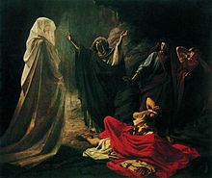](https://en.wikipedia.org/wiki/File:Witch_of_Endor_(Nikolay_Ge).jpg)*fear because of Samuel's words. His strength was gone, for he had eaten nothing all that day and night. 21 When the woman came to Saul and saw that he was greatly shaken, she said, "Look, your maidservant has obeyed you. I took my life in my hands and did what you told me to do. 22 Now please listen to your servant and let me give you some food so you may eat and have the strength to go on your way." (Witch of Endor* by [Nikolai Ge](https://en.wikipedia.org/wiki/Nikolai_Ge), 1857.)

Martin Luther said it was the “Devil’s ghost,” and John Calvin said it was “not the real Samuel but a spectre.” Rudyard Kipling wrote a poem called “En-Dor” about the supposed ability to communicate with the dead. He summarizes my view”

“On the road to En-Dor is the oldest road

And the craziest road of all!

Straight it runs to the Witch’s abode,

As it did in the days of Saul,

And nothing has changed of the sorrow in store

For such as go down on the road to En-Dor!”

My view is that it probably was an impersonating demon. There is some chance that God did allow this one situation for his own purposes. What leads me to entertain this otherwise prohibited action is that the Scripture says it was Samuel without any hesitation or qualification. Whether it was an impersonating demon or actually Samuel, it either case the means of communication was forbidden and had as much to do with Saul’s death as the Philistines. Demons destroy. It is what they do. There is “sorrow in store” for those who go the “road to En-Dor”

Three hundred years after Saul, it seems that Isaiah understood the lesson of Saul who consulted those who “peep and mutter.” Isaiah 8:19-22 “*When men tell you to consult mediums and spiritists, who whisper and mutter, should not a people inquire of their God? Why consult the dead on behalf of the living? 20 To the law and to the testimony! If they do not speak according to this word, they have no light of dawn. 21 Distressed and hungry, they will roam through the land; when they are famished, they will become enraged and, looking upward, will curse their king and their God. 22 Then they will look toward the earth and see only distress and darkness and fearful gloom, and they will be thrust into utter darkness.*

“To the law and the testimony!” That is, look to the Scripture. It is the lamp to our feet and light to our path. If you don’t go the pathway of the Scripture you will seek other revelations and other knowledge. In the end, it will lead to distress, rage, and the cursing of God. Having gone against God, they will look to the earth and see only distress, darkness, and gloom which is merely the prelude to utter darkness and separation from God. That is the pathway of Endor and apparently of much of America today.

One final reflection on the two bookends to stories surrounding the end of Saul. The Witch of Endor was complicit in Saul’s evil and contributed to his demise. The men of Jabesh Gilead were noble in spite of Saul’s evil and gave us an illustration of dignity in the face of evil.

|  |  |  |
| --- | --- | --- |
|  |  |  |

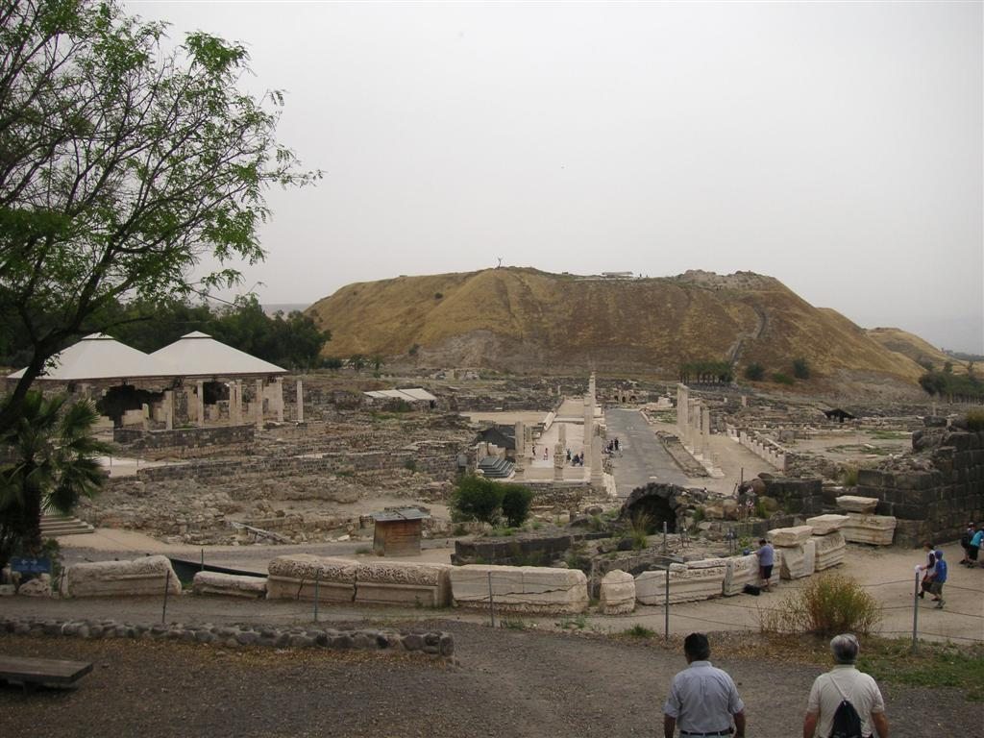**Saturday, June 27**

**Beit Shean.**

Looking at the hill in the background that once supported the walls of the city, it is hard to imagine the bodies of Saul and Jonathan hanging from those city walls. Yet 3,000 years ago this is where it happened. Even by the time of Saul it was an old city. The excavations have revealed settlements here going back into the Bronze Age. The Egyptians used it as an administrative center during the XVIII and XIX dynasties. By Roman times, they turned it into the center of the Decapolis. The main ruins seen in the foreground are from the Roman period.

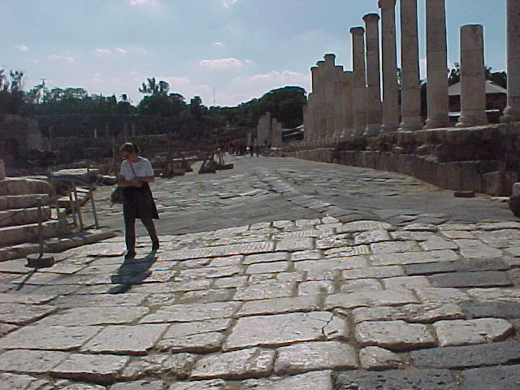 Walking down these ruined streets we can begin to imagine the Romans (Byzantines as we call them now) who lived here. On one of my trips, my son Zach found a coin in the large amphitheater. Apparently one of its 7,000 occupants got too excited and lost the coin out of his toga. The Byzantine era colonnaded street, ritual baths, pottery workshop, basilica, and Roman temple remind us of those days. This is today one of the finest excavation Roman ruins in the world.

From this city, we can look over the start of the Jordan River valley as it exits Galilee and begins its mad tumble to the Dead Sea (at least that is the way it was when the Jordan still had water in it.)

Visiting Beth Shan today the ancient city sat on top of the hill while the Roman and Byzantine city was built on the hillside above the ancient hill.