**Great Moments in and around Jezreel**

**Mt. Tabor**

Pastor Emeritus Joe Fuiten, January 25, 2017

We are studying the key people and events that took place around the Valley of Jezreel also known as the Valley of Armageddon. Last week it was about Gideon and Jezebel. Tonight we will cross to the other side of the valley where another “judge” will get the spotlight revealing another foreshadowing of the Battle of Armageddon.  
 After the conquest of Canaan under the leadership of Joshua, the Israelis entered a rather chaotic period for the next roughly 400 years. They had no central government. In times of trouble, however, God raised up judges. The judges were charismatic leaders who rallied the people to meet whatever enemy was oppressing them at the time. There were about a dozen judges in all. Only one of the dozen was a woman. Under her leadership a forty-year period of peace was ushered in.

Deborah was a “mother in Israel” who inspired the victory. She saw the need for action because of the oppression of Jabin, King of Hazor. She heard the word of the Lord that now was the time to do something. She sent out the summons to Barak to go to the battle. In order for the victory to be won, she had to accompany Barak to the place of battle.[1] She didn’t do the fighting, but she was the catalyst for the positive outcome. In that sense she was the “mother” to the fighting men. She wanted Barak to get the credit, but it ended up going to her.

In the Scripture, the opening reads like this in Judges chapter 4. “*After Ehud died, the Israelites once again did evil in the eyes of the LORD. 2 So the LORD sold them into the hands of Jabin, a king of Canaan, who reigned in Hazor. The commander of his army was Sisera, who lived in Harosheth Haggoyim. 3 Because he had nine hundred iron chariots and had cruelly oppressed the Israelites for twenty years, they cried to the LORD for help.*

*4 Deborah, a prophetess, the wife of Lappidoth, was leading Israel at that time. 5 She held court under the Palm of Deborah between Ramah and Bethel in the hill country of Ephraim, and the Israelites came to her to have their disputes decided. 6 She sent for Barak son of Abinoam from Kedesh in Naphtali and said to him, "The LORD, the God of Israel, commands you: 'Go, take with you ten thousand men of Naphtali and Zebulun and lead the way to Mount Tabor. 7 I will lure Sisera, the commander of Jabin's army, with his chariots and his troops to the Kishon River and give him into your hands.'"*

They won a great victory against the technologically better equipped army. After their victory they celebrated what had happened. Judges 5 has that celebration. “*1 On that day Deborah and Barak son of Abinoam sang this song: 2 "When the princes in Israel take the lead, when the people willingly offer themselves-- praise the LORD! 3 "Hear this, you kings! Listen, you rulers! I will sing to the LORD, I will sing; I will make music to the LORD, the God of Israel. 4 "O LORD, when you went out from Seir, when you marched from the land of Edom, the earth shook, the heavens poured, the clouds poured down water. 5 The mountains quaked before the LORD, the One of Sinai, before the LORD, the God of Israel. 6 "In the days of Shamgar son of Anath, in the days of Jael, the roads were abandoned; travelers took to winding paths. 7 Village life in Israel ceased, ceased until I, Deborah, arose, arose a mother in Israel.*

Before drawing some conclusions about the events let us first look at the various places involved. **The key places are Mt. Tabor, Hazor, and the Kishon River in the valley**.

When God changes things, there is a sequence. First, leaders arise. Verse 7 says it plainly: *7 Village life in Israel ceased, ceased until I, Deborah, arose, arose a mother in Israel.*

Deborah was an unusual leader mostly because she was a woman. She was the only woman mentioned among the Judges. That seems typical. Women never formed the bulk of the leadership but there were always women who stepped to the front as they were called by God. Deborah is a good example in the Old Testament, and Junias, an outstanding Apostle mentioned in Acts 16, would be a New Testament version. It seems that women were not prohibited from leadership but comprised a definite minority of leaders throughout the Bible.

Deborah was a wise decision maker who could settle disputes. She was also a prophetess who knew God. In short, she acted like a mother. When God raises up leaders, you can sometimes be surprised at how unlikely they are. It may be that there are women listening to me today who will play decisive roles in our next victories.

Secondly, people step up. The victory song began like this: “*1 On that day Deborah and Barak son of Abinoam sang this song: 2 "When the princes in Israel take the lead, when the people willingly offer themselves-- praise the LORD!*

It takes a leader to lead but if no one is following you are just taking a walk. Leaders lead but people follow. That happened in Israel. Barak was a reluctant warrior but with Deborah’s leadership he stepped up. When God changes things, you get both leaders and followers.

Thirdly, strategies and circumstances to overcome deficits and defects are found which glorify God. In those days, iron chariots were the latest and greatest military hardware. Deborah said that the enemies were lured down into the valley where maybe the softer ground diminished the effectiveness of the chariots or a sudden downpour left the ground soggy and impassable. We don’t have all the details. There is just a hint that the River Kishon swept them away. Well if the river was capable of sweeping people away it says that a whole lot of rain had fallen on the land quite suddenly. In that circumstance, I think we see one of God’s foreshadowing of future events.

Hazor was a dominant city in Deborah’s time period. Recent discoveries have found evidence of a temple suggesting a particular point to how Sisera was defeated.  His iron chariots would have been a significant technological advantage in the open field.  Of course, that advantage quickly turned into a disaster when heavy rains turned the plowed fields to sticky mud.  God using this method to destroy the army of Sisera is rich.

            In Hazor they have excavated a temple to the storm god.  The storm god was supposed to help them by way of storms.  Rain in the appropriate season sustains life.  The former rain in the fall causes seeds to germinate while the latter rain in the spring causes the grain heads to plump up and mature.  Without those rains the people starve.  So the god who controlled the moisture including the dew was always among the chief deities of any land and all ancient people had such gods.  In Canaan the chief deity was Baal.  The term was originally an epithet applied to the storm god [Hadad](http://encyclopedia2.thefreedictionary.com/Hadad). Technically, Baal was subordinate to El, the supreme god, the creator, and the father of Hadad and other gods.

In “Baal, God of Thunder” by Jimmy Dunn writing as Taylor Ray Ellison he says it like this:  “Baal was the source of the winter rain storms, spring mist and summer dew which nourished the crops. However, Baal also became associated with the deity of other sites such as Baal Hazor in Palestine, Baal-Sidon and Baal of Tyre (Melkart) in Lebanon.

“Baal was known to be a rider of clouds, most active during storms but was also considered to be a "lord of heaven and earth", even controlling earth's fertility. He was the god of thunderstorms, the most vigorous and aggressive of the gods and the one on whom mortals most depended. Some of his other common epithets include " Most High Prince/Master", " Conqueror of Warriors", Mightiest, Most High, Supreme, Powerful, Puissant", “Warrior", and "Prince, Master of the Earth". He is also sometimes called Re'ammin, meanign "Thunderer", as well as Aleyin, meaning "Most High", Mightiest", "Most Powerful", or Supreme and he has many, many other epithets.”

Given the role of Baal and the titles given to him, you can imagine that the Heavenly Father might look for an opportunity to set things right.  This much I know about God, He is competitive and loves a good contest.  God is not only competitive but he is fair.  He gave Sisera his choice of weapons.  No doubt Sisera paid a visit to the temple of the storm god before he set out from Hazor to tame the rebels.  So Sisera chose the storm god for his protector and God accepted the terms of battle sending storms to destroy Sisera.

If you want to know how to apply a story like this consider King David who would later think about these things when great enemies came against him.  David’s worship leader wrote a prayer song about Israel’s enemies.  Ps 83:9-18 “*Do to them as you did to Midian, as you did to Sisera and Jabin at the river Kishon, 10 who perished at Endor and became like refuse on the ground. 11 Make their nobles like Oreb and Zeeb, all their princes like Zebah and Zalmunna,  12 who said, "Let us take possession of the pasturelands of God."  13 Make them like tumbleweed, O my God, like chaff before the wind. 14 As fire consumes the forest or a flame sets the mountains ablaze, 15 so pursue them with your tempest and terrify them with your storm. 16 Cover their faces with shame so that men will seek your name, O Lord. 17 May they ever be ashamed and dismayed; may they perish in disgrace. 18 Let them* *know that you, whose name is the Lord — that you alone are the Most High over all the earth.*”

The conclusion of the story is too good to pass up. In the biblical account. Barak whipped up on the army of Sisera but General Sisera himself escapes. He runs for friendly territory and comes upon a lady named Jael. “*18 Jael went out to meet Sisera and said to him, "Come, my lord, come right in. Don't be afraid." So he entered her tent, and she put a covering over him. 19 "I'm thirsty," he said. "Please give me some water." She opened a skin of milk, gave him a drink, and covered him up. 20 "Stand in the doorway of the tent," he told her. "If someone comes by and asks you, 'Is anyone here?' say 'No.'"*

What a sympathetic ear! Poor Sisera! Nobody appreciated him and they were treating him so badly. “You poor thing, come in and I will take care of you, not like those other bad people. They really don’t love you but I do.”

Now guys, take note, if some woman starts giving you the “they don’t understand but I do” treatment things may not be headed for as happy an ending as you might imagine.

Jael understood the situation clearly. You could say she nailed it right on the head. There was a problem but she pinned it down right away. Poor Sisera! He got taken in and taken down in the same day. Earlier an iron chariot carried him over the ground but now an iron nail pinned him to the ground. All Sisera got out of it was a medical condition named after him: “splitting head-ache.” And that woman gave it to him.

This was Jael’s moment. She was another of those celebrated “willing volunteers.” She had her 15 minutes of fame, but we still talk about her 3400 years later.

I said at the beginning that we can find in this battle a foreshadowing of the Battle of Armageddon. The concluding phrase of the song suggests that as well. "*So may all your enemies perish, O LORD! But may they who love you be like the sun when it rises in its strength.*" *Then the land had peace forty years.*” The Battle of Armageddon will be like Deborah’s battle. The enemies of God will be trusting in their demon gods who will bring them to the battle. Just like Sisera who was failed by the storm god, so the anti-Christ forces will be failed by their gods and the Great God, the Lord Almighty will win a victory. The ensuing peace will not be forty years for 1,000 years when Jesus wins his battle

Isaiah 29:5-8 describes how it will all go down. “*But your many enemies will become like fine dust, the ruthless hordes like blown chaff. Suddenly, in an instant, 6 the Lord Almighty will come with thunder and earthquake and great noise, with windstorm and tempest and flames of a devouring fire. 7 Then the hordes of all the nations that fight against Ariel, that attack her and her fortress and besiege her, will be as it is with a dream, with a vision in the night — 8 as when a hungry man dreams that he is eating, but he awakens, and his hunger remains; as when a thirsty man dreams that he is drinking, but he awakens faint, with his thirst unquenched. So will it be with the hordes of all the nations that fight against Mount Zion.”*

**The Transfiguration took place on a “high mountain**.” The exact mountain is not mentioned but the most frequent choices are either Mt. Hermon because it is the highest mountain or Mt. Tabor. I am inclined toward Mt. Tabor because of its relative location and because I can’t see why anyone would climb into the snow of Hermon just to reach the highest point in that land. I suspect Jesus looked at Tabor often during his growing up years because it is a short distance from Nazareth and immediately visible if Jesus went into the Nazareth hills to pray. We can be sure the story of Deborah took place on Tabor because the Bible says exactly that. We can be less certain about the location of the transfiguration

*1 After six days Jesus took with him Peter, James and John the brother of James, and led them up a high mountain by themselves. 2 There he was transfigured before them. His face shone like the sun, and his clothes became as white as the light. 3 Just then there appeared before them Moses and Elijah, talking with Jesus. 4 Peter said to Jesus, "Lord, it is good for us to be here. If you wish, I will put up three shelters-- one for you, one for Moses and one for Elijah." 5 While he was still speaking, a bright cloud enveloped them, and a voice from the cloud said, "This is my Son, whom I love; with him I am well pleased. Listen to him!" 6 When the disciples heard this, they fell facedown to the ground, terrified. 7 But Jesus came and touched them. "Get up," he said. "Don't be afraid." 8 When they looked up, they saw no one except Jesus. 9 As they were coming down the mountain, Jesus instructed them, "Don't tell anyone what you have seen, until the Son of Man has been raised from the dead."*

The Transfiguration, literally the metamorphosis of Jesus, gives us a rare glimpse into heaven. On this earth, Jesus was a man but he was also God. He had two feet on the earth yet he touched heaven. The glory of Jesus was revealed. We get a hint of the greatness of his heavenly glory when we see that his radiance literally shines through his clothes. (I wonder if Julia Howe, who wrote “The Battle Hymn of the Republic,” had heard a recent sermon on this subject because one verse of her hymn reads “In the beauty of the lilies Christ was born across the sea, with a glory in His bosom that transfigures you and me.” It is such an unusual combination of the words “glory” and “transfigures” it almost certainly had to be so. I also suspect that Martin Luther King’s speech, “I have been to the mountaintop” has this text in mind.)

The voice from heaven, the same voice that spoke at the Epiphany spoke again *"This is my Son, whom I love; with him I am well pleased. Listen to him!"* Based on verses like this it is not hard to be a Trinitarian.

The appearance of Moses and Elijah in some recognizable form lets us know that the transition from earth to heaven is a continuum in our existence rather than the end of one and the beginning of another. We are not something wholly different but we are still us even if our bodies are somewhat different. Fifteen hundred years had passed since Moses, but it was still Moses. Nearly a millennium had passed since Elijah was taken up to heaven but it was still Elijah. A thousand years from now this physical body will be long gone but I will forever be Joe Fuiten and I will exist. Although there was a time when you did not exist, there will never again be a time when you won’t exist. For good or ill, we are forever and we are conscious.

Remembering the original Jewish audience, this must have been a particularly important moment, a symbolic event from which everything going forward was to be seen in its light. This event is the Law and the Prophets coming alive in Jesus. Moses is a representative of the Law given on Mt. Sinai. More than that, the appearance of Moses shows that the spiritual law is in perfect harmony with Jesus. The Law finds its fulfillment in Jesus. In the same way, Elijah is seen as the greatest, and thus representative of the Prophets. Jesus is the ultimate Prophet. He is all mystery revealed. All that was suggested, hinted at, or went before, culminates in Jesus. The Jewish person would be convinced that Jesus was not in conflict with the former but a complete continuation of what God had revealed in the past. It also helps us appreciate who Jesus is. In a sense, Moses and Elijah lend their full support to the importance of Jesus with Moses representing all law and Elijah representing all prophets and revelation. Going forward, is law the answer? Many politicians seem to think so. Is mystery the answer? New Agers seem to think so. Is it Torah or Nevi’im? Here we see that Jesus is not just another prophet, or another religious leader. This is someone special, unique, the very Son of God.

We get a sense of the priority ranking when Peter wants to build a monument to each of the three. The voice from heaven puts a stop to that. This is my Son, “LISTEN TO HIM.”

Here is how Origen described the importance of the scene. “…*there will appear to him who beholds Jesus in such form Moses, - the law - and Elijah, - in the way of synecdoche,[2] not one prophet only, but all the prophets -- holding converse with Jesus; for such is the force of the words "talking with Him;" but, according to Luke, "Moses and Elijah appeared in glory…" But if any one sees the glory of Moses, having understood the spiritual law as a discourse in harmony with Jesus, and the wisdom in the prophets which is hidden in a mystery, he sees Moses and Elijah in glory when he sees them with Jesus.*”[3]

Seeing Moses and Elijah raised certain questions, one of which was how they could understand Elijah as having lived but coming again in some way. In the Passover even today, a place is set for Elijah. There was some more enduring element to Moses and Elijah which was only reinforced in the Transfiguration.

*10 The disciples asked him, "Why then do the teachers of the law say that Elijah must come first?" 11 Jesus replied, "To be sure, Elijah comes and will restore all things. 12 But I tell you, Elijah has already come, and they did not recognize him, but have done to him everything they wished. In the same way the Son of Man is going to suffer at their hands." 13 Then the disciples understood that he was talking to them about John the Baptist.*

The disciples knew that a forerunner would prepare for the Lord’s coming. The Prophet Malachi spoke for God when he said, *"See, I will send my messenger, who will prepare the way before me. Then suddenly the Lord you are seeking will come to his temple; the messenger of the covenant, whom you desire, will come," says the LORD Almighty*.[4] This person was identified as Elijah who had been taken up into heaven in the chariot of fire. Indeed, the prophecy ends with the words: *"Remember the law of my servant Moses, the decrees and laws I gave him at Horeb for all Israel. "See, I will send you the prophet Elijah before that great and dreadful day of the LORD comes. He will turn the hearts of the fathers to their children, and the hearts of the children to their fathers; or else I will come and strike the land with a curse."[5]*

In this passage John’s mission is so different from Elijah’s with Ahab and Jezebel on Carmel. Here it is a compassionate reuniting of families. He will be the messenger of reconciliation. How did Elijah go from one who called down fire from heaven into the instrument of God’s peace in the home? In the ancient work of Ben Sira, who lived about 180 BC and is often quoted in the Talmud, it says that Elijah had used fire three times. Once was on Mt. Carmel and twice against the soldiers of Ahaziah.[6] When he was taken up to heaven it was by a chariot of fire. The Rabbi’s said that he would thereafter leave the fire in heaven and substitute kindness and reconciliation.

Jesus refers to what John the Baptist did. That is, he brought reconciliation to families. For that, he was killed. Jesus said he would do what John did, and suffer the same ingratitude. It seems there is an almost universal ingratitude affecting even nations. When I think of how America has been responding to Christianity it is the same as the response to the Savior. No good deed will go unpunished. I hope that changes soon.

Jesus also observed that John will come and “restore all things.” Some have suggested that the same two that showed up at the transfiguration will be the two witnesses of Revelation. There they will be restoring things in preparation for the earthly return of Jesus.[7] As an element of biblical interpretation it is worth noting that we have three iterations of Elijah. We have the original Elijah, John the Baptist as Elijah, and the Elijah who will come. This is a classic style.

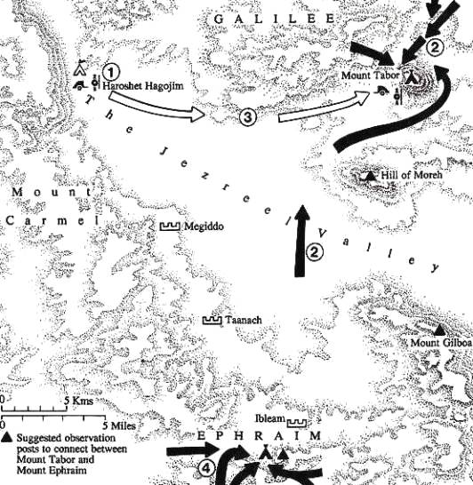

***(Above) The terrain for the battle between Deborah and Sisera. Plan of the first phase of the battle between Deborah's forces and Sisera. 1: Sisera's base camp; 2: Deborah and Barak concentrate their forces on Mt. Tabor; 3: Sisera moves to invest Mt. Tabor; 4: the second Israelite force concentrates near the northern slopes of Mt. Ephraim. From 'Battles of the Bible', Chaim Herzog and Mordechai Gishon. The chariots of the well-organised and equipped Canaanite army were useless in the boggy marsh of the Jezreel Valley - it had recently poured with rain. The lightly armed and mobile Israelite militia used their slingmen and archers to pick off the enemy soldiers.***

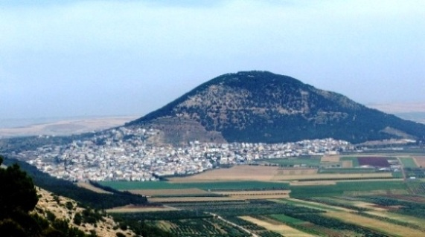

***Mount Tabor and the Jezreel Valley below, scene of the battle between Deborah/Barak's forces and Sisera, the fearsome general of King Jabor of Hazor (see Judges 4 and 5). King Jabor and his general Sisera counted on their iron-wheeled chariots, which were effective on the flat plain below Mount Tabor. What they did not foresee was the torrential rain that turned the ground into a quagmire, and gave the lightly armed Israelites the advantage. For more information on Deborah and the battle, see*** [***Deborah and Barak: Battle***](http://www.bible-archaeology.info/deborah_sisera.htm)

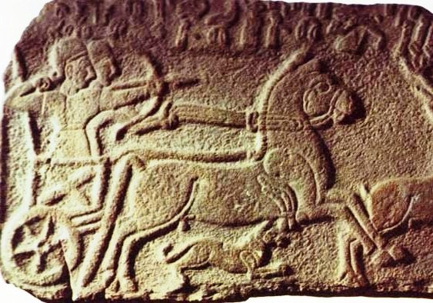

***The iron-wheeled chariots of the Canaanite troops. See*** [***Warfare: Chariots***](http://www.bible-archaeology.info/chariots.htm)***or***[***Warfare: Armor***](http://www.bible-archaeology.info/armor.htm)

Despite their undoubted courage, the tribal militias were not really successful. Their enemies, such as the Philistines, were well-organized - 1 Samuel 4:2 tells us that the Philistines were drawn up in lines when they attacked Israel, which suggests a disciplined, well-trained enemy. Moreover, the Israelites were poorly equipped, with little or no armor.

When King Saul, and then [**King David**](http://www.bible-people.info/David.htm) and his son [**King Solomon**](http://www.bible-people.info/Solomon.htm) took the throne, there was a dramatic change. These kings began to copy the strategies of their enemies. David had fought Goliath with nothing but a sling and his wits. (Read about David's use of lateral thinking at [**Young Heroes of the Bible**](http://www.womeninthebible.net/young_people_OT.htm).)

Later when he became king, he took care to organize and equip an army that would have a better chance of defeating its enemy. He and the kings who followed him formed regular armies with full-time trained soldiers. They used new strategies and tactics, things that worked well for their enemies - for example, laying siege to a city. But they also held onto the tactics that had worked for them before: surprise attacks, psychological warfare, propaganda.

***Note: Very little is known about the organization of the army under the Israelite kings. When the Bible speaks of soldiers in 'thousands', it does not mean numerical thousands, but is instead a term describing a unit of soldiers. Unfortunately, we do not know how many soldiers would have been in one of these units - but certainly it would have been much, much less than a numerical 'thousand'.***

Weapons

There were four branches in the army: spearmen, [**swordsmen**](http://www.bible-archaeology.info/swords.htm), [**archers**](http://www.bible-archaeology.info/bow_arrow.htm), and [**slingers**](http://www.bible-archaeology.info/slings.htm). Weapons used by these groups can be divided into two groups: those the soldier held and wielded at close quarters with the enemy, and those he projected, either with his arm or with the help of some other centrifugal force, for example the sling.

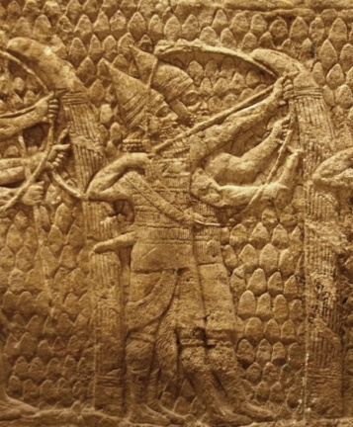There are few references to weapons in the period of the Judges, or in the battles that were fought then - no Israelite spears, [**bows**](http://www.bible-archaeology.info/bow_arrow.htm), [**shields**](http://www.bible-archaeology.info/shields.htm), javelins, [**axes**](http://www.bible-archaeology.info/axe_warfare.htm) or [**maces**](http://www.bible-archaeology.info/axe_warfare.htm) - or the protective body [**armor**](http://www.bible-archaeology.info/armor.htm) (see Judges 5:8). Their enemies, on the other hand, were well armed - [**Goliath**](http://www.bible-archaeology.info/david_goliath.htm) had a full suit of armor. The Assyrian archers at right had not only their bows and arrows, but full body armor, helmets and large wicker shields to protect them.

After the introduction of the monarchy by Saul, David and Solomon, weapons became much more common. The standing army was equipped with effective weapons, and when the Philistine control over the manufacture of metal was broken, the weapons industry of Israel came under the control of the king.

Hand held weapons included the [**sword**](http://www.bible-archaeology.info/swords.htm), the [**mace**](http://www.bible-archaeology.info/axe_warfare.htm) or club, and spears and javelins. Projectile weapons using centrifugal force included the [**bow and arrow**](http://www.bible-archaeology.info/bow_arrow.htm), and the [**sling**](http://www.bible-archaeology.info/slings.htm). The slingers were probably more accurate at hitting their target than the archers.

Judg 4:1-6:1

4:1 After Ehud died, the Israelites once again did evil in the eyes of the LORD. 2 So the LORD sold them into the hands of Jabin, a king of Canaan, who reigned in Hazor. The commander of his army was Sisera, who lived in Harosheth Haggoyim. 3 Because he had nine hundred iron chariots and had cruelly oppressed the Israelites for twenty years, they cried to the LORD for help.

4 Deborah, a prophetess, the wife of Lappidoth, was leading Israel at that time. 5 She held court under the Palm of Deborah between Ramah and Bethel in the hill country of Ephraim, and the Israelites came to her to have their disputes decided. 6 She sent for Barak son of Abinoam from Kedesh in Naphtali and said to him, "The LORD, the God of Israel, commands you: 'Go, take with you ten thousand men of Naphtali and Zebulun and lead the way to Mount Tabor. 7 I will lure Sisera, the commander of Jabin's army, with his chariots and his troops to the Kishon River and give him into your hands.'"

8 Barak said to her, "If you go with me, I will go; but if you don't go with me, I won't go." 9 "Very well," Deborah said, "I will go with you. But because of the way you are going about this, the honor will not be yours, for the LORD will hand Sisera over to a woman." So Deborah went with Barak to Kedesh, 10 where he summoned Zebulun and Naphtali. Ten thousand men followed him, and Deborah also went with him.

11 Now Heber the Kenite had left the other Kenites, the descendants of Hobab, Moses' brother-in-law, and pitched his tent by the great tree in Zaanannim near Kedesh.

12 When they told Sisera that Barak son of Abinoam had gone up to Mount Tabor, 13 Sisera gathered together his nine hundred iron chariots and all the men with him, from Harosheth Haggoyim to the Kishon River.

14 Then Deborah said to Barak, "Go! This is the day the LORD has given Sisera into your hands. Has not the LORD gone ahead of you?" So Barak went down Mount Tabor, followed by ten thousand men. 15 At Barak's advance, the LORD routed Sisera and all his chariots and army by the sword, and Sisera abandoned his chariot and fled on foot. 16 But Barak pursued the chariots and army as far as Harosheth Haggoyim. All the troops of Sisera fell by the sword; not a man was left.

17 Sisera, however, fled on foot to the tent of Jael, the wife of Heber the Kenite, because there were friendly relations between Jabin king of Hazor and the clan of Heber the Kenite.

18 Jael went out to meet Sisera and said to him, "Come, my lord, come right in. Don't be afraid." So he entered her tent, and she put a covering over him. 19 "I'm thirsty," he said. "Please give me some water." She opened a skin of milk, gave him a drink, and covered him up. 20 "Stand in the doorway of the tent," he told her. "If someone comes by and asks you, 'Is anyone here?' say 'No.'"

21 But Jael, Heber's wife, picked up a tent peg and a hammer and went quietly to him while he lay fast asleep, exhausted. She drove the peg through his temple into the ground, and he died.

22 Barak came by in pursuit of Sisera, and Jael went out to meet him. "Come," she said, "I will show you the man you're looking for." So he went in with her, and there lay Sisera with the tent peg through his temple — dead.

23 On that day God subdued Jabin, the Canaanite king, before the Israelites. 24 And the hand of the Israelites grew stronger and stronger against Jabin, the Canaanite king, until they destroyed him.

Judges 5

5:1 On that day Deborah and Barak son of Abinoam sang this song:

2 "When the princes in Israel take the lead, when the people willingly offer themselves — praise the LORD!

3 "Hear this, you kings! Listen, you rulers! I will sing to the LORD, I will sing; I will make music to the LORD, the God of Israel.

4 "O LORD, when you went out from Seir, when you marched from the land of Edom, the earth shook, the heavens poured, the clouds poured down water. 5 The mountains quaked before the LORD, the One of Sinai, before the LORD, the God of Israel.

6 "In the days of Shamgar son of Anath, in the days of Jael, the roads were abandoned; travelers took to winding paths. 7 Village life in Israel ceased, ceased until I, Deborah, arose, arose a mother in Israel. 8 When they chose new gods, war came to the city gates, and not a shield or spear was seen among forty thousand in Israel. 9 My heart is with Israel's princes, with the willing volunteers among the people. Praise the LORD!

10 "You who ride on white donkeys, sitting on your saddle blankets, and you who walk along the road, consider 11 the voice of the singers at the watering places. They recite the righteous acts of the LORD, the righteous acts of his warriors in Israel.

"Then the people of the LORD went down to the city gates. 12'Wake up, wake up, Deborah! Wake up, wake up, break out in song! Arise, O Barak! Take captive your captives, O son of Abinoam.'

13 "Then the men who were left came down to the nobles; the people of the LORD came to me with the mighty. 14 Some came from Ephraim, whose roots were in Amalek; Benjamin was with the people who followed you. From Makir captains came down, from Zebulun those who bear a commander's staff. 15 The princes of Issachar were with Deborah; yes, Issachar was with Barak, rushing after him into the valley. In the districts of Reuben there was much searching of heart. 16 Why did you stay among the campfires to hear the whistling for the flocks? In the districts of Reuben there was much searching of heart. 17 Gilead stayed beyond the Jordan. And Dan, why did he linger by the ships? Asher remained on the coast and stayed in his coves. 18 The people of Zebulun risked their very lives; so did Naphtali on the heights of the field.

19 "Kings came, they fought; the kings of Canaan fought at Taanach by the waters of Megiddo, but they carried off no silver, no plunder. 20 From the heavens the stars fought, from their courses they fought against Sisera. 21 The river Kishon swept them away, the age-old river, the river Kishon. March on, my soul; be strong! 22 Then thundered the horses' hoofs — galloping, galloping go his mighty steeds. 23'Curse Meroz,' said the angel of the LORD. 'Curse its people bitterly, because they did not come to help the LORD, to help the LORD against the mighty.'

24 "Most blessed of women be Jael, the wife of Heber the Kenite, most blessed of tent-dwelling women. 25 He asked for water, and she gave him milk; in a bowl fit for nobles she brought him curdled milk. 26 Her hand reached for the tent peg, her right hand for the workman's hammer. She struck Sisera, she crushed his head, she shattered and pierced his temple. 27 At her feet he sank, he fell; there he lay. At her feet he sank, he fell; where he sank, there he fell-dead.

28 "Through the window peered Sisera's mother; behind the lattice she cried out, 'Why is his chariot so long in coming? Why is the clatter of his chariots delayed?' 29 The wisest of her ladies answer her; indeed, she keeps saying to herself, 30'Are they not finding and dividing the spoils: a girl or two for each man, colorful garments as plunder for Sisera, colorful garments embroidered, highly embroidered garments for my neck — all this as plunder?'

31 "So may all your enemies perish, O LORD! But may they who love you be like the sun when it rises in its strength."

Then the land had peace forty years.

NIV

DEBORAH

2. The prophetess and judge = "a bee," a personal or possibly an official name applied to poets, seers, and priestesses. The symbol of a monarch in Egypt; a honey bee to her friends, a stinging bee to the enemy (Cornelius a Lapide). "Lived under the palm tree"; a landmark, as palms were rare in Palestine (Judg 4:5); possibly = Baal Tamar, "the sanctuary of the palm" (Judg 20:33). Wife of Lapidoth; "a mother in Israel," a patriotic and inspired heroine like Miriam. Jabin oppressed the northern tribes adjacent to Hazor his capital (Zebuhn, Naphtali, and Issachar, which she judged). Barak, at her call, summoned these (to whom the central tribes, Ephraim, Manasseh (Machir), and Benjamin in part sent contingents, Judg 20:14) in a long train (draw: Judg 5:6-7) toward the broad topped mount Tabor. Deborah accompanied him at his request. With but 10,000 in his train ("at his feet"), by the Lord's interposition, descending from Mount Tabor, he defeated Sisera's mighty host and 900 chariots who were in the famous battlefield of Jezreel or Esdraelon, in the valley of Kishon. Deborah's prediction was fulfilled by the "Lord's selling Sisera into the hand of a woman," namely, Jael, the Kenite Heber's wife. Enthusiasm for the cause of Israel, so closely allied with the Kenites through Moses' father-in-law Hobab, caused her to commit the treacherous murder.

The praise, "blessed above women in the tent (i.e. shepherdesses) shall Jael the wife of Heber the Kenite be" commends her faith, not her treachery. Some actions of faith are mixed with the corrupt motions of the flesh, as that of the midwives and Rahab's treatment of the spies. So Jael's act showed real faith in the case of God's controversy with the godless Canaanites. The approval of her faith, the mainspring of her conduct, by no means implies approval of the deceit by which its true character was obscured. Yet faith is precious and "blessed" in spite of grievous infirmities, and will at last outgrow and stifle them utterly. God is keen to see the faith, slow to condemn the fault, of His children.

Deborah and Barak together sang the song of victory composed by her. It begins with a reference to Jehovah's original, grand, and awful manifestation at Sinai (Ex 19; Deut 33:2), the sealing of the covenant with Israel, and the ground of all His subsequent interpositions for them. Then follows Israel's deep degradation, its highways deserted, its 40,000 soldiers (a round number for a diminished army) without shield or spear, because they forsook Jehovah for "new gods" (compare Deut 32:17). Then "war (pressed up) to their (very) gates." But now deliverance is come, for which "bless the Lord." All should join in "speaking" His praise: the upper classes "who ride upon white-spotted asses," and those "that sit upon coverings" (

middin

, the rich, Matt 21:7) spread upon the asses; also the humbler "who walk on the way," foot travelers. Those delivered from the plundering "archers "who infest "the places of drawing water" to plunder the shepherds, shepherdesses, and their flocks in lawless times (Ex 2:17), should rehearse there, now that all is peace, "the Lord's righteous acts." "Then shall the people of Jehovah go down [from their past mountain hiding places] to their gates" and towns now delivered.

"Barak, lead away thy captivity (train of captives) captive" (quoted in Ps 68:18); fulfilled exhaustively in Christ the ascended Conqueror (Eph 4:8,13). "Out of Zebulun came they that handle the pen of the writer," i.e. the scribes of the host (Jer 52:25) who wrote down the names of the soldiers. "Barak was sent by his feet into the valley," i.e. impelled irresistibly to the battle. "At the brooks of Reuben were great resolutions of the heart," but issuing in no practical action, the tribe resembling their forefather. Reuben preferred hearing "the bleatings of the flocks" to the blast of the war trumpets. Dan with its port Joppa preferred merchandise to warring for the fatherland. "Asher abode in his bags." "The kings of Canaan took no gain of money," i.e. no booty, as they expected, from the battle; for "the stars from heaven fought against Sisera;" i.e., a Jehovah-sent storm beat in their faces and on the Israelites' back (Josephus), swelling the Kishon, which suddenly fills up the dry channel and overflows the plain of Esdraelon, making it impassable with mud, especially to chariots, so that the" prancing horses" and their "mighty" riders were swept away. Meroz might have intercepted the retreating foe and Sisera, but is "cursed by the angel of Jehovah" for not doing so; and Jael is blessed" for her zeal, though mixed with earthly alloy. So "the land had rest for 40 years." See BARAK. Neither Ehud nor Jael are in the list of examples of faith in Heb 11. Jael apparently received Sisera in good faith, with the intention of hospitality, but a sudden impulse may have urged her to destroy the enemy of God's people. Her faith and patriotism are commendable, but not the means she took of delivering Israel.

(from Fausset's Bible Dictionary, Electronic Database Copyright © 1998, 2003, 2006 by Biblesoft, Inc. All rights reserved.)

**Great Moments in and around Jezreel**

Pastor Emeritus Joe Fuiten, January 17, 2017

The Jezreel valley is one of the main geographic features of Israel and the Bible. It is where the battle of Armageddon will take place. So many great biblical figures have walked its pathways including Elijah, Gideon, Deborah, and so many kings of Israel. All kinds of important biblical and historic events took place within and around its boundaries.

Over the last 4,000 years Egyptians, Canaanites, Israelites, Philistines, Hasmoneans, Greeks, Muslims, Crusaders, Mongols, Ottomans, Britons, Germans, Arabs and Israelis have all been locked in great battles on Jezreel. Some 34 battles from Pharaoh Pepi I around 2350 BC to Napoleon, to the Jewish wars in 1948, 1967, and 1973 have taken place within the valley. There is good reason for this long history. The topography is the key. It is the easy link from the Mediterranean Sea to the Jordan River connecting Egypt with Mesopotamia. Further, any north-south travel has to pass through this valley. It has always been a key transit point.

First let’s use a map to locate some of the main places we will consider. I will walk you around the valley in pictures to give you some perspective on the places we will visit on these Wednesday nights.

Mt. Carmel is a long range of hills overlooking the valley and is the place where Elijah had his fiery encounter with the false prophets before the bloody conclusion at the Kishon River that flows from Gilboa to the Mediterranean Sea.

Megiddo is on a hill overlooking Jezreel and gave its name to that famous final battle. Har Megiddo is “mountain of Megiddo” from which we get “Armageddon.” The city is on a hill at about the midpoint of the east-west axis and at the head of a mountain pass and is a natural position to be the controlling stronghold of the region. Such a position is probably one reason it has been destroyed and rebuilt 26 times over the centuries.

Those dozens of armies had their moment in the sun but are nothing compared to the great final battle of Armageddon which will take place in this same valley when Jesus returns to defeat the enemies of God and establish his rule on earth.

Revelation 16:12-16 “*The sixth angel poured out his bowl on the great river Euphrates, and its water was dried up to prepare the way for the kings from the East. 13 Then I saw three evil spirits that looked like frogs; they came out of the mouth of the dragon, out of the mouth of the beast and out of the mouth of the false prophet. 14 They are spirits of demons performing miraculous signs, and they go out to the kings of the whole world, to gather them for the battle on the great day of God Almighty. 15 "Behold, I come like a thief! Blessed is he who stays awake and keeps his clothes with him, so that he may not go naked and be shamefully exposed." 16 Then they gathered the kings together to the place that in Hebrew is called Armageddon.”*

King Saul, the first king of Israel and his son Jonathan died on Mt. Gilboa overlooking the valley. The last independent Davidic king, the good King Josiah was killed in the valley in 609 BC. As an illustration of the strategic importance of the valley, the battle in which Josiah was killed was against Pharaoh Necho II, King of Egypt who was on his way to join Egypt’s ally Assyria against Babylonia, the Medes, Persians and Scythians at the Battle of Carchemish on the banks of the Euphrates. Ironically, only when Christ returns in the battle of Armageddon will the next good Davidic king be in power in his place. It will be at least a 2600 year gap between Josiah and Jesus, the good kings of the Jews.

In a moment we will consider Gideon whose main life events took place at the foot of Mt. Gilboa where a spring comes out of a cave.

Queen Jezebel took a tumble from the walls that had a valley view. Continuing in the same direction we will come to Mt. Tabor where Deborah and Barak defeated Sisera and which is celebrated as the mountain of the Transfiguration.

On a little farther we will come to the place where the people of Nazareth tried to throw Jesus off the cliff. These and many more places are part of this great valley.

Tonight, I would like to give a closer examination to Gideon and his experience which landed him in the Hebrews 11 Hall of Fame. That story is found in Judges 6-7 and dates to around 1300 BC.

Chapter six begins with an all too human account. Israel did evil in God’s sight so God allowed the Midianites to dominate them for seven years. Every year at harvest time these marauding Midianites would invade Israel. Verse 5 says they would come in like locusts, ravaging the land. What they couldn't carry off they destroyed. They came at harvest time and cleaned the area of harvest and animals. Each year the people of the area became progressively poorer and weaker.

The fear of these invading terrorists became so great people left their homes to live in caves, strongholds, or other defensible positions. Out of their great fear and poverty, they began to turn to God for help. I don’t know why we are like this but it seems to be the way humans act. When things are great we are self-made people. But when things go awry we discover we need God and actually begin to pray. C.S. Lewis said, "God whispers to us in our pleasures, speaks in our conscience, but shouts in our pains. It's His megaphone to rouse a deaf world."

Judges 6 “*Again the Israelites did evil in the eyes of the Lord, and for seven years he gave them into the hands of the Midianites. 2 Because the power of Midian was so oppressive, the Israelites prepared shelters for themselves in mountain clefts, caves and strongholds. 3 Whenever the Israelites planted their crops, the Midianites, Amalekites and other eastern peoples invaded the country. 4 They camped on the land and ruined the crops all the way to Gaza and did not spare a living thing for Israel, neither sheep nor cattle nor donkeys. 5 They came up with their livestock and their tents like swarms of locusts. It was impossible to count the men and their camels; they invaded the land to ravage it. 6 Midian so impoverished the Israelites that they cried out to the Lord for help.*

*7 When the Israelites cried to the Lord because of Midian, 8 he sent them a prophet, who said, "This is what the Lord, the God of Israel, says: I brought you up out of Egypt, out of the land of slavery. 9 I snatched you from the power of Egypt and from the hand of all your oppressors. I drove them from before you and gave you their land. 10 I said to you, 'I am the Lord your God; do not worship the gods of the Amorites, in whose land you live.' But you have not listened to me."*

*11 The angel of the Lord came and sat down under the oak in Ophrah that belonged to Joash the Abiezrite, where his son Gideon was threshing wheat in a winepress to keep it from the Midianites. 12 When the angel of the Lord appeared to Gideon, he said, "The Lord is with you, mighty warrior." 13 "But sir," Gideon replied, "if the Lord is with us, why has all this happened to us? Where are all his wonders that our fathers told us about when they said, 'Did not the Lord bring us up out of Egypt?' But now the Lord has abandoned us and put us into the hand of Midian." 14 The Lord turned to him and said, "Go in the strength you have and save Israel out of Midian's hand. Am I not sending you?" 15 "But Lord," Gideon asked, "how can I save Israel? My clan is the weakest in Manasseh, and I am the least in my family." 16 The Lord answered, "I will be with you, and you will strike down all the Midianites together."*

As I have mentioned literally dozens of great armies would cross this same ground over the centuries. The natural break in the hills allowed easier east-west travel. It was also a natural passage to and from Egypt. Where Haifa now sits has long been a natural harbor for shipping and those armies that come by sea. The exact place where the Midianites were hanging out is part of a long history of battles. The unstoppable Mongels were turned back by the Mamlukes on almost exactly the same spot some 2500 years later.

In the story of Gideon we see the unlikely people that God uses to accomplish his purposes. (As an aside, the Midianites were also the descendants of Abraham by way of Katurah his concubine.) In v. 11 Gideon is threshing wheat in a winepress to keep it from the Midianites. Normally, you would want to thresh wheat out in the open so that the wind could blow away the chaff. But Gideon was so fearful of having his crop taken he used a winepress. Instead of working openly he is down in a winepress trying to separate the wheat. Throughout the story there are multiple examples of a timid or anxiety-ridden man. Yet God calls him something else in v. 12: “*Then the Angel of the LORD appeared to him and said: "The LORD is with you, mighty warrior*." It was a great “Who? Me?” moment.

Gideon is not only timid but he suffers from bad but quite common theology. Gideon responded to God with a question: "*Please Sir, if the LORD is with us, why has all this happened? And where are all His wonders that our fathers told us about*?" (v. 13) Gideon's conclusion was that the Lord has abandoned them in the past and would surely do so again in the future. The danger of questioning what God has done in the past is that it tends to immobilize you for the future.

God sidestepped the question with a directive. The Lord turned to him and said, "*Go in the strength you have and deliver Israel from the power of Midian. Am I not sending you?"* Gideon completely ignores the assumption God makes about the outcome. Instead he assesses himself and realizes how unimpressive his resume is. He has a weak clan and he is the youngest in his family. He lacks the authority to call upon his clan and his age seems to work against his authority with others.

God shows him why he should be confident. "*I will be with you," the LORD said to him. "You will strike Midian down [as if it were] one man."* Gideon is given an undeniable commission, told the remarkable results in advance, and promised the unrivaled partnership of the Lord Himself. After further confirmation that he was in fact, dealing with God Himself, v. 22 tells us that the pieces fell into place for Gideon. He cries out, "*Oh no, Lord GOD! I have seen the Angel of the LORD face to face!*" His fears comforted, his calling affirmed, he builds an altar to the Lord.

He tears down the idols and makes a sacrifice of his dad’s bull to the Lord. I guess the lesson is if you want to defeat the external enemies you better clean up your own house. Private relationship with God precedes public victory.

Of course if you get out of your lane not everybody will like it. Verse 30 reports that the men of the city said to Joash, "*Bring out your son. He must die*." Thankfully his father, Joash, was inspired by his son and stood up to the men, asking in v. 31, "*Would you plead Baal's case for him? . . . If he is a god, let him plead his own case.*"

Once Gideon led the way and made the call 32,000 men followed his lead. But God wanted to receive the glory for the success so he set about that famous thinning process. In Judges 7:2, the Lord said to Gideon, "*You have too many people for Me to hand the Midianites over to you, or else Israel might brag: 'I did it myself.*'" God proceeds to give Gideon a couple of tests to whittle the number down. The first test culled 22,000 men out of the army, leaving 10,000. Still too many, said God. So in v. 4, a second test was given. God tells Gideon to take his men down to the water and let them drink. Weed out any men who stick their face down into the water to drink; keep the ones who ladle the water to their mouths with their hands. Gideon must have gulped hard when he counted how many were disqualified: another 9700 were out, leaving only 300 men.

Imagine how Gideon felt. Chapter 8 indicates the Midianite army numbered 135,000 men, 450 Midianites to every Israeli soldier. God wants Gideon's army to face this horde with a mere 300 men who know how to drink politely!

God created an impossible situation of human weakness to exalt His own strength. This is His specialty! What did Jesus say in Luke 18:27? "*What is impossible with men is possible with God.*"

In one of the strangest battle strategies in history, the 300 went out with trumpets, torches, and jars to meet the marauding Midianites. God sent confusion into the ranks of the enemy so that they began attacking each other. When it was over, 120,000 Midianites had killed one another and the other 15,000 fled.

The next event to consider was several centuries after Gideon but only a short distance away. Gideon’s battle was at the foot of Mt. Gilboa. Jezreel the city is at the most western point of the Gilboa range as it fades into the valley. It was a city where several of Israel’s kings resided and the city which gave its name to the valley. Elijah ran the 20 miles to Jezreel from his great victory on Mt. Carmel. One of the more grim and legendary stories of Jezreel is found in 2 Kings 9:30-37.

*“Then Jehu went to Jezreel. When Jezebel heard about it, she painted her eyes, arranged her hair and looked out of a window. 31 As Jehu entered the gate, she asked, "Have you come in peace, Zimri, you murderer of your master?" 32 He looked up at the window and called out, "Who is on my side? Who?" Two or three eunuchs looked down at him. 33 "Throw her down!" Jehu said. So they threw her down, and some of her blood spattered the wall and the horses as they trampled her underfoot. 34 Jehu went in and ate and drank. "Take care of that cursed woman," he said, "and bury her, for she was a king's daughter." 35 But when they went out to bury her, they found nothing except her skull, her feet and her hands. 36 They went back and told Jehu, who said, "This is the word of the Lord that he spoke through his servant Elijah the Tishbite: On the plot of ground at Jezreel dogs will devour Jezebel's flesh. 37 Jezebel's body will be like refuse on the ground in the plot at Jezreel, so that no one will be able to say, 'This is Jezebel.'"*

**Jezreel Valley**

Also known as Campus Legionis, Esdraelon, Esdraelon Valley, Plain of Megiddo, Plains of Megiddo, Great Plain, Great Plain of Esdraelon, Great Plain of Megiddo, Merj ibn-'Amir, Plain of Megiddo, “The Valley,” Valley of Megiddon

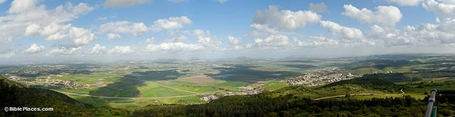

The spacious Jezreel Valley spreads out to the north and east from Mount Carmel, providing convenient passage for international travelers in ancient times.  The fertile alluvial soil makes this the country’s breadbasket as well.  The Bible speaks of the gathering of armies in this valley at the place of Armageddon.

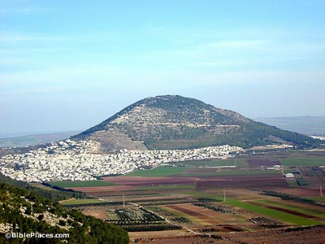

**Mount Tabor**

From the Nazareth ridge, Mt. Tabor looms large to the east.  While some tradition ascribes the transfiguration of Jesus to this place, it more likely occurred in the area around Caesarea Philippi.  Deborah and Barak camped on Mt. Tabor with the Israelite army before attacking and defeating Sisera’s Canaanite force.



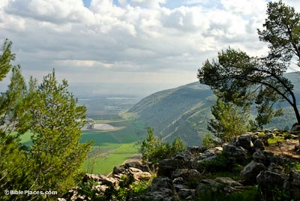

**Mount Gilboa**

Mount Gilboa is on the southeastern side of the Jezreel Valley.  King Saul felt forced to commit suicide on these slopes when facing certain defeat by the Philistines.  In light of Saul and Jonathan’s deaths, David cursed the mountain: “O mountains of Gilboa, may you have neither dew nor rain, nor fields that yield offerings” (2 Sam 1:21).

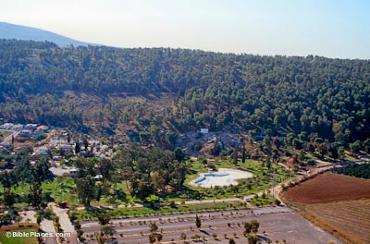

**Ein Harod**

At the foot of Mount Gilboa is Ein (the spring of) Harod.  Judges 7 describes Gideon’s actions in thinning his army out.  He brought the men to the spring and sorted them on the basis of how they drank from the water.  Today the swimming pool sits just in front of the cave where the spring emerges.



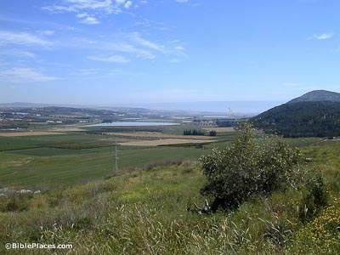

**Harod Valley**

This fantastic view is filled with biblical history.  From this location on Tel Jezreel looking east, one can almost picture the anointed (but not yet crowned) Jehu “driving like a madman,” on his way to killing the kings of Israel and Judah.  900 years later, Jesus healed the

**Mount Tabor**

Also known as Har Tavor, Itabyrium, Jebel et-Tur, Mount of Transfiguration



**From the west**

Mt. Tabor sits at the eastern end of the Jezreel Valley, 11 miles (17 km) west of the Sea of Galilee. Its elevation at the summit is 1,843 feet (575 m) high.  It is used in Scripture as a symbol of majesty. Jeremiah 46:18 (NASB) “‘As I live,’ declares the King Whose name is the Lord of hosts, ‘Surely one shall come who looms up like Tabor among the mountains, Or like Carmel by the sea’” (cf. Ps 89:12).

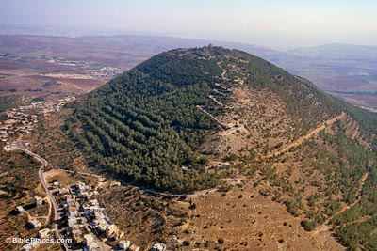

**Deborah's Battle**

The Israelite tribes gathered on Mount Tabor in the days of Deborah.  The Canaanites were assembled at Harosheth Haggoyim (likely on the opposite side of the Jezreel Valley) and Barak led the Israelite charge of 10,000 men against Sisera’s army.  It seems that the Lord’s intervention on behalf of the Israelites was in the form of a rainstorm, such that the Kishon River flooded and made chariot travel for the Canaanites impossible (Judges 4-5).



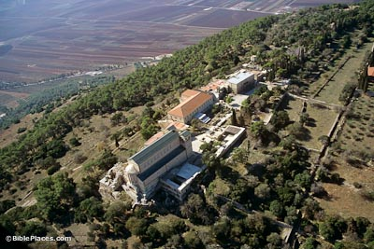

**Tradition**

Early Church fathers believed that the Transfiguration took place on Mt. Tabor, including Cyril of Jerusalem (in 348), Epiphanius, and Jerome. Eusebius was uncertain if it took place on Mt. Tabor or on Mt. Hermon. One reason for this identification was a misunderstanding of Matthew 17:1. This verse was taken to mean that Jesus took the disciples up a mountain “by itself,” rather than that he took the disciples up a mountain “by themselves.”

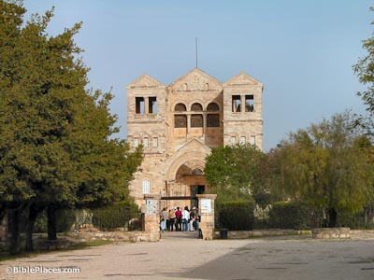

**Basilica of the Transfiguration**

The date of the earliest churches on Mt. Tabor is unknown. The Anonymous Pilgrim of Piacenza saw three basilicas in 570. Willibaldus, in 723, mentions only one church dedicated to Jesus, Moses, and Elijah. There may have been three chapels joined together into one building, as in the present building. The current church was built in 1924 and belongs to the Franciscans.



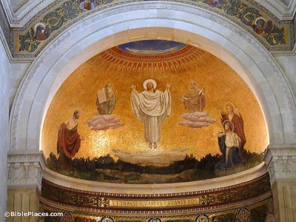

**The Transfiguration**

Mt. Tabor is probably not the location for the Transfiguration: (1) Jesus and his disciples are in the region of Caesarea Philippi just prior to the Transfiguration. (2) The general location of the mountain is not isolated. Much traffic passed by through the Jezreel Valley below. (3) A military fort was located on top of the mountain and was clearly in use during the Hasmonean period and the time of the Jewish Revolt, and likely would have been in Jesus’ day as well.

**Megiddo**

Also known as Armageddon, el-Lejjun, Tel el-Mutesellium, Tell el-Mutesellim, Tel Megiddo, Campus Legionis, Har Megiddo, Har-Megeddon, Harmagedon, Isar-Megiddo, Legio, Lejjun, Megiddon

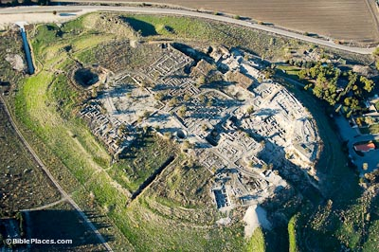

**Megiddo Excavations**

Inhabited from the Chalcolithic period, Megiddo has approximately 26 levels of occupation.  American excavators from the Oriental Institute worked from 1925 with the ambitious goal of excavating every level in its entirety.  They made it through the first three levels before concentrating the work on certain areas.

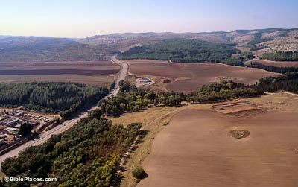

**Megiddo Pass**

From the earliest times (EB) to the earliest historical records of the area (Thutmose III) to the future (Revelation 16), Megiddo assumes a prominent role.  This is largely owing to its strategic location astride the Megiddo Pass (Wadi Ara) and inside the busy Jezreel Valley.  The modern road follows the ancient one; the tell is just off the bottom right corner.



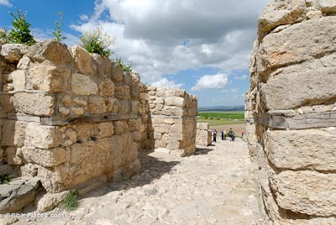

**Middle Bronze Gate**

Strongly fortified throughout the ages, Megiddo boasted a stone Syrian-type gate in the days of Canaanite inhabitation.

This gate is later than the bent-axis gate (straightened to accommodate chariots) and earlier than the famous “Solomonic” gate, part of the construction of King Solomon described in 1 Kings 9:15.

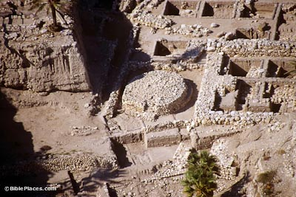

**Early Bronze Altar**

Part of a large religious complex from the third millennium B.C., this sacrificial altar is striking in its size (10m diameter) and location (behind the temple).

A staircase leads up to the altar, a small temenos fence surrounded it, and large concentrations of animal bones and ashes were found in the vicinity.



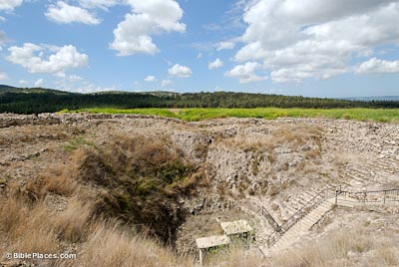

**Iron Age Watersystem**

Needing secure access to its water supply, Megiddo utilized different watersystems over its history.

In the 9th c. BC, Ahab constructed a massive system with a 30 meter deep shaft and a 70 meter long tunnel.  This continued in use until the end of the Iron Age.

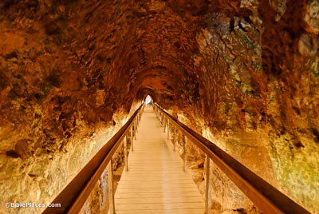

**Tunnel to Spring**

This Iron Age tunnel connected the bottom of Ahab’s shaft to the spring. Before its construction, Megiddo residents had to leave the city walls in order to get water from the spring.

This tunnel was hewn from both ends at the same time (like Hezekiah’s Tunnel) and its builders were only one foot off when meeting in the middle.



1. Judges 4:8-9 “*Barak said to her, "If you go with me, I will go; but if you don't go with me, I won't go." 9 "Very well," Deborah said, "I will go with you. But because of the way you are going about this, the honor will not be yours, for the LORD will hand Sisera over to a woman." So Deborah went with Barak to Kedesh*, (NIV)
2. A figure of speech in [which](http://dictionary.reference.com/browse/which) a part is used for the whole or the whole for a part, the special for the general or the general for the special.
3. John Patrick, D.D., "Origen's Commentary on the Gospel of Matthew" Book XII, Chapter XXXVIII, Ante-Nicene Fathers, Vol. 9.
4. Malachi 3:1
5. Malachi 4:4-6
6. II Kings 1:10 “Elijah answered the captain, "If I am a man of God, may fire come down from heaven and consume you and your fifty men!" Then fire fell from heaven and consumed the captain and his men.”
7. Rev. 11:1-5 *I was given a reed like a measuring rod and was told, "Go and measure the temple of God and the altar, and count the worshipers there. But exclude the outer court; do not measure it, because it has been given to the Gentiles. They will trample on the holy city for 42 months. And I will give power to my two witnesses, and they will prophesy for 1,260 days, clothed in sackcloth." These are the two olive trees and the two lampstands that stand before the Lord of the earth. If anyone tries to harm them, fire comes from their mouths and devours their enemies. This is how anyone who wants to harm them must die.*