**Revelation 10**

Pastor Emeritus Joe Fuiten, Wednesday March 18. 2020 live streamed from Ethel

Too bad I am not still on chapter 6 and the four horsemen of the apocalypse since quite a few probably think we are there. In that chapter as the black horse rides goes out it’s rider holds a pair of scales and a voice says “*"A quart of wheat for a day's wages, and three quarts of barley for a day's wages…”* Change that to a roll of toilet paper or a bottle of hand sanitizer for a day’s wages and it would be closer to it.

In biblical language, having to measure your bread, the most common staple, describes the judgment of God. *When I cut off your supply of bread, ten women will be able to bake your bread in one oven, and they will dole out the bread by weight. You will eat, but you will not be satisfied*.[1]

The fourth seal and the fourth horseman are inevitable consequences of the previous horsemen. *7 When the Lamb opened the* ***fourth seal****, I heard the voice of the fourth living creature say, "Come!" 8 I looked, and there before me was a* ***pale horse****! Its rider was named Death, and Hades was following close behind him. They were given power over a fourth of the earth to kill by sword, famine and plague, and by the wild beasts of the earth.*”

I don’t truly think we are there as I think those things happen after the rapture of the church but it is not as hard as it used to be to convince people this could happen any time.

The feeling of powerlessness or helplessness that people feel today is very much like what the Christians of the first century were feeling. In that time it was because of the persecution from Rome. All up and down the coast of what is now Turkey people would have been huddled together reading these words from the last of the Apostles who had traveled with Jesus. Everyone would have known that John had been banished to the island of Patmos. They certainly knew that the Emperor was on a rampage against Christians with the latest news always containing an account of someone else who was in prison or killed.

In that time the church was neither powerful nor numerous. At the human, military, or political level they were pretty much at the mercy of Rome and Rome was not merciful. Christians were disenfranchised and defenseless, a weak minority unable to assert themselves even for survival. In the message to the people of Smyrna God said (Revelation 2:10) “*Do not be afraid of what you are about to suffer. I tell you, the devil will put some of you in prison to test you, and you will suffer persecution for ten days. Be faithful, even to the point of death, and I will give you the crown of life*.”

If you are going to get the maximum out of this Scripture you need to put yourself in that place. Indeed, maybe you are in that place. Certainly a lot of people have felt like that as they have struggled to be beneficially employed or to make house payments. Maybe it is your relative youth or your relative old age that is making you feel powerless. Maybe it is the general state of your health or the Wuhan Coronavirus. There are a lot of things these days that can make us feel that way.

In this passage, we see how God spoke to those in the first century who were in our position. Given the current sense of fear and anxiety surrounding the coronavirus I am hopeful it will help you to consider it.

**10:1** *Then I saw another mighty angel coming down from heaven. He was robed in a cloud, with a rainbow above his head; his face was like the sun, and his legs were like fiery pillars. 2 He was holding a little scroll, which lay open in his hand. He planted his right foot on the sea and his left foot on the land, 3 and he gave a loud shout like the roar of a lion. When he shouted, the voices of the seven thunders spoke. 4 And when the seven thunders spoke, I was about to write; but I heard a voice from heaven say, "Seal up what the seven thunders have said and do not write it down." 5 Then the angel I had seen standing on the sea and on the land raised his right hand to heaven. 6 And he swore by him who lives for ever and ever, who created the heavens and all that is in them, the earth and all that is in it, and the sea and all that is in it, and said, "There will be no more delay! 7 But in the days when the seventh angel is about to sound his trumpet, the mystery of God will be accomplished, just as he announced to his servants the prophets." 8 Then the voice that I had heard from heaven spoke to me once more: "Go, take the scroll that lies open in the hand of the angel who is standing on the sea and on the land." 9 So I went to the angel and asked him to give me the little scroll. He said to me, "Take it and eat it. It will turn your stomach sour, but in your mouth it will be as sweet as honey." 10 I took the little scroll from the angel's hand and ate it. It tasted as sweet as honey in my mouth, but when I had eaten it, my stomach turned sour. 11 Then I was told, "You must prophesy again about many peoples, nations, languages and kings."* NIV

Let’s start at the last verse. John’s prophecy was about individuals but also beyond the individual and to “peoples, nations, languages and kings.” God is always interested in personal salvation but also in the wider application of his truth. There is the matter of your personal salvation but also of letting your light shine before people.

The chapter begins with a description of a mighty angel which is so characteristic of Jesus that it must be Jesus himself. Don’t be thrown off by the word “angel” since that is a title or function and not the nature of a being. Angel means messenger. “*Then I saw another mighty angel coming down from heaven. He was robed in a cloud, with a rainbow above his head; his face was like the sun, and his legs were like fiery pillars*.”

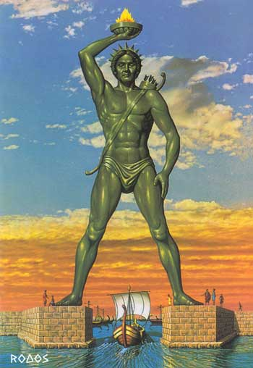This is quite an amazing description to us. But in the first century it would have been much less so. We read this and see this angel “Jesus” raising his hand and speaking and we don’t find anything in it that we recognize. However, one of the memories of the ancient world was The Colossus of Rhodes, a 110 foot tall statue of the Greek Titan Helios. Helios was the personification of the sun. Among the Romans it was Sol but the Greeks called him Helios. It was finished around 280 BC and brought down by an earthquake in 226 BC. Ironically, Helios was almost exactly the same size as the statue of liberty and was in a similar position with arm raised.

Once the Colossus of Rhodes fell, it lay on the land for the next 800 years and continued to draw visitors for centuries right up to the time of John and well beyond. Even on the ground, it was amazing. In ancient times Rhodes and Patmos were closely connected. In fact still today, the ferry goes every day between Patmos and Rhodes.

Here Jesus is bigger and more grand than their sun god, the Colossus of Rhodes. He is clothed in a cloud. It is a function of his size as when Mt. Rainer is clothed in a cloud but it also speaks of his mystery. He can be seen but he is also obscured. God appeared on Mt. Sinai in a dark cloud and over the Mercy Seat in a cloud. He led Israel as a pillar of cloud.

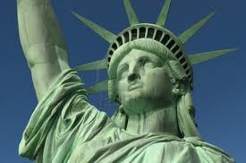 He has “a rainbow.” We remember God’s throne from Revelation 4:3 “*A rainbow, resembling an emerald, encircled the throne*.” We remember what God said in Genesis 9:13-15 “*I have set my rainbow in the clouds, and it will be the sign of the covenant between me and the earth. 14 Whenever I bring clouds over the earth and the rainbow appears in the clouds, 15 I will remember my covenant between me and you and all living creatures of every kind*.” Christ is appearing on the earth again but he comes as a promise keeping God. Even as he reasserts his ownership of the earth, he does so with his promises in mind. There is a judgment coming, but it will not be random or arbitrary but according to promises made.

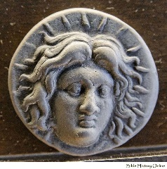“*His face was like the sun.”* Our statue of liberty has the radiating spikes off her head which represent the rays of the sun. It is like so many coins of the ancient world, including this one from Rhodes, which represent Helios or Sol, their sun gods. But Jesus comes as the authentic face like the sun.

*“and his legs were like fiery pillars.”* His whole body is a blaze of sun and fire. This is their sun god on steroids. He is bigger and badder then anything they have ever seen or imagined.

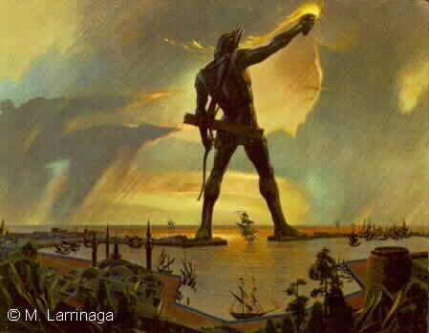The Colossus of Rhodes may have straddled the harbor entrance. Some think not but he is always pictured that way. Today the harbor of Rhodes has a deer on a column on either side of the harbor but in ancient times it was the colossus.

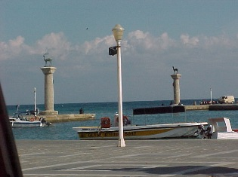Compare that to Jesus. “*He planted his right foot on the sea and his left foot on the land, 3 and he gave a loud shout like the roar of a lion. When he shouted, the voices of the seven thunders spoke.”* To place one’s feet in a place is to lay claim to it. So Jesus is here laying claim to the earth and the sea. The Lion of Judah roars and thunder breaks forth.

This is all pretty powerful stuff. A suffering and powerless people have a powerful God. The sun god of the Greeks and Romans is lying in ruins at Rhodes but the Almighty God stands astride the earth and the sea. Emperor Domitian, the persecutor of the Apostle John, thinks of himself as a god, but Jesus claims the land and sea for himself.

But there is a problem with the promises of God. They don’t always seem to come about. Jesus spoke of it in Matthew 13:17. “*For I tell you the truth, many prophets and righteous men longed to see what you see but did not see it, and to hear what you hear but did not hear it*.” The writer of Hebrews adds his perspective on the delay. Hebrews 11:13 “*All these people were still living by faith when they died. They did not receive the things promised; they only saw them and welcomed them from a distance*.”

You may recognize that problem. It is not that you don’t believe the promises of God it is just that they don’t always seem to arrive on time or at all.

What was promised by the Isaiah seems not always to be so. “*In righteousness you will be established: Tyranny will be far from you; you will have nothing to fear. Terror will be far removed; it will not come near you. If anyone does attack you, it will not be my doing; whoever attacks you will surrender to you. "See, it is I who created the blacksmith who fans the coals into flame and forges a weapon fit for its work. And it is I who have created the destroyer to work havoc; no weapon forged against you will prevail, and you will refute every tongue that accuses you. This is the heritage of the servants of the LORD, and this is their vindication from me," declares the LORD*.[2]

When you are feeling overwhelmed by life and its troubles it is easy to lose heart just as the early Christians were inclined to do. You know that Christ should rule but the forces of evil often gain the upper hand. When those early Christians saw Domitian and his evil schemes succeeding, they needed an answer and they found it in this chapter. “*5 Then the angel I had seen standing on the sea and on the land raised his right hand to heaven. 6 And he swore by him who lives for ever and ever, who created the heavens and all that is in them, the earth and all that is in it, and the sea and all that is in it, and said, "There will be no more delay*!”

A passage like this does confirm to us that delay is a feature of the spiritual life today. The promises don’t always arrive on schedule today and there remains a bit of a mystery around that. To say there will be no more delay is to acknowledge there is delay now. But it also points us to a better day.

This is the great day for which we wait. Things will be made right. There will be justice. Every sickness will be healed, every need met, every tear dried. Death itself will be destroyed. Things damaged by the fall will be repaired by the arrival of the King.

There is a message to every “*people, nation, language and king."* It is the message that the king is coming to take his rightful place over every life and every nation.

1. Lev 26:26
2. Isaiah 54:14-17.