**Revelation 12--Summarizing All Spiritual Conflict**

Pastor Emeritus Joe Fuiten, April 15, 2020

This message will help you know why the Jews always seem to be hated in the world. It will help you know why you have been opposed all your life. You have always and will always have to fight or die. Given this great conflict, this passage will tell you what the essential elements are for success.

First, consider the biblical text. “*A great and wondrous sign appeared in heaven: a woman clothed with the sun, with the moon under her feet and a crown of twelve stars on her head.[1] 2 She was pregnant and cried out in pain as she was about to give birth. 3 Then another sign appeared in heaven: an enormous red dragon with seven heads and ten horns[2] and seven crowns on his heads. 4 His tail swept a third of the stars out of the sky and flung them to the earth. The dragon stood in front of the woman who was about to give birth, so that he might devour her child the moment it was born. 5 She gave birth to a son, a male child, who will rule all the nations with an iron scepter.[3] And her child was snatched up to God and to his throne. 6 The woman fled into the desert to a place prepared for her by God, where she might be taken care of for 1,260 days.*

We meet two characters, a woman and a dragon. Both are signs as opposed to literal figures or creatures as verse 1 clearly states.

We meet these two characters here because through them we can view the whole story from Genesis to Revelation, or better said, from beginning to end. This is the whole moral story of the world told in a few sentences. In a way, this chapter is the pivot or center point of the book of Revelation and what follows in subsequent chapters are parallel to the previous chapters.[4] In previous chapters the kingdoms of this world became the kingdom of our Lord and of his Christ. The rest of the book goes back through that same territory. Chapter 12 is the story behind the story. It is the explanation of the program of this world and what has been happening 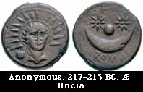all along.

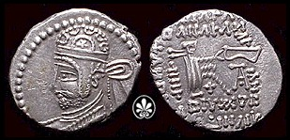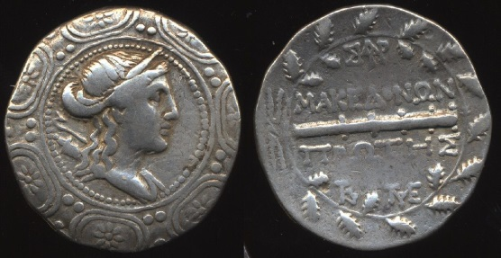 The woman is presented in superlative fashion. Nothing greater could be said about the woman. She is “*clothed with the sun, with the moon under her feet and a crown of twelve stars on her head.”*  You know me! I enjoy ancient coins because they give us such a clear window on the ancient mindset. The coin in the center has the sun, moon, and stars, evidence of providential blessing on some great ruler. The coin on the right is of a Parthian ruler from John’s time period, with the moon and stars in his crown or helmet. One of my favorite coins is the Artemis coin (left) from Amphipolis which is a shield with moon and stars edging the shield. It is a common theme from great leaders in John’s era symbolizing the favor of heaven. The appearance of such a well-known sign in heaven communicated this woman represented a favored people. One, three, five, or seven stars were common. Twelve stars never appear on any ancient coin so the number is unique. However, there were twelve tribes of Israel and twelve apostles who are represented later in Revelation on the twelve gates of heaven so we have good reason to conclude this woman represents the people of God.

The dragon is not a tough guess. Verse 9 is explicit this is Satan, the devil, the old accuser. He wants to destroy the woman, the people of God, and particularly the “Son of Man” who is “*coming in clouds with great power and glory.*”[5] The dragon has at least two beasts who do his bidding, but whatever the face, dragon-breath is the same.

Chapter 12 describes and summarizes a very old battle. It started in the Garden of Eden and continues up to the end. It was the subject of the very first prophecy. Gen 3:15 “*And I will put enmity between you and the woman, and between your offspring and hers; he will crush your head, and you will strike his heel."* From the moment Adam and Eve were expelled from the Garden of Eden God’s people have been an expectant mother awaiting the birth of the Son who would defeat that ancient liar, the devil.

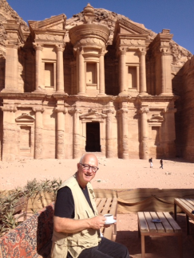 From our earlier studies of Revelation we remember how extensively Domitian was persecuting the church in John’s time. Revelation must have helped the persecuted church know their suffering was part of the ancient struggle but that God would be with them and protect them. Verse 6 “*The woman fled into the desert to a place prepared for her by God, where she might be taken care of for 1,260 days.”*

After 1812 when Petra was rediscovered by Europeans, it became popular to use Petra as a potential site to which God’s people might flee in the future in order to be protected by God. It is a pretty amazing place but Indiana Jones did more to connect Petra to the Bible than we might make from reading Revelation 12.

However, John did want suffering people to know that God himself would provide the hiding place and prevent the devil’s victory over his people. The dragon and his surrogate beasts are fierce indeed, but the chapter shows their defeat.

*7 And there was war in heaven. Michael and his angels fought against the dragon, and the dragon and his angels fought back. 8 But he was not strong enough, and they lost their place in heaven. 9 The great dragon was hurled down — that ancient serpent called the devil, or Satan, who leads the whole world astray. He was hurled to the earth, and his angels with him. 10 Then I heard a loud voice in heaven say: "Now have come the salvation and the power and the kingdom of our God, and the authority of his Christ. For the accuser of our brothers, who accuses them before our God day and night, has been hurled down* (skipping ahead)

*13 When the dragon saw that he had been hurled to the earth, he pursued the woman who had given birth to the male child. 14 The woman was given the two wings of a great eagle, so that she might fly to the place prepared for her in the desert, where she would be taken care of for a time, times and half a time, out of the serpent's reach. 15 Then from his mouth the serpent spewed water like a river, to overtake the woman and sweep her away with the torrent. 16 But the earth helped the woman by opening its mouth and swallowing the river that the dragon had spewed out of his mouth. 17 Then the dragon was enraged at the woman and went off to make war against the rest of her offspring — those who obey God's commandments and hold to the testimony of Jesus.*

In this brief chapter you have the back story to the war in which God’s people have always been engaged. The names of the persecutors and enemies change with each generation but there is always the same devil behind it. God’s people have always been hounded. Anti-Semitism has always been there and it is really anti-God. Anti-Christian sentiment was among not the Romans and Pagans alone, but has found its way into the modern era with Islam and with the aggressive atheists. It might be a University professor, Congresswoman, or a Hollywood producer who provides the face, but it is the dragon underneath the façade. It can have a thousand names like pluralism, multi-culturalism, or dignity but there is a force behind it. They might say it is about divestiture of Israeli products or companies but the actual roots go back to the Garden of Eden.

The war against Jesus and his people is the defining activity of all time. You may not believe it or you may not know it, but that war is swirling around you this very minute and every minute of your life.

Let’s go back to the Revelation about this conflict. *10 Then I heard a loud voice in heaven say: "Now have come the salvation and the power and the kingdom of our God, and the authority of his Christ. For the accuser of our brothers, who accuses them before our God day and night, has been hurled down. 11 They overcame him by the blood of the Lamb and by the word of their testimony[6]; they did not love their lives so much as to shrink from death. 12 Therefore rejoice, you heavens and you who dwell in them! But woe to the earth and the sea, because the devil has gone down to you! He is filled with fury, because he knows that his time is short."*

Whether it is first century or twenty-first century the sides are the same. It is war. Always has been, always will be. Some don’t believe the Dragon exists, but the Dragon doesn’t mind that. It actually helps his cause.

John does mention a pathway to victory. He evokes the Nike image in the word “overcame.” Victory is three-fold. The blood of the lamb is essential. It is that blood which covers your sins. That blood moves you from the dragon’s lair to Lamb’s chair. It is worth pausing and asking a question. In this cosmic battle, are you depending on and trusting in the Blood of the Lamb?

The accuser of the brothers might make you feel like the blood is not effective. The devil’s job is to bring up all your failures, to make you give up. Everyone has them. But God’s job is to cover those failures with the blood of the Lamb. Your job is to trust God that he does a better job covering up than the devil does bringing up. Christ crucified is a victory foundation.

The word of their testimony is the second essential. They had to give evidence they were trusting in Christ. That evidence was their testimony. Telling people what Jesus has done for you in terms of mercy and grace is important for our side to have success.

The third essential is to love God more than you love your life, even to the point of death. If you are unwilling to die for Jesus you are not prepared to successfully live for Jesus. Jesus has to be first in your life. This is true in the ultimate sense of being willing to die for the Lord. For most of us we don’t die in one fell swoop. Instead we lay our lives down one moment at a time as we serve God and serve others on this earth. We die daily, even hourly and in dying we live eternally.

1. Gen 37:9 *Then he had another dream, and he told it to his brothers. "Listen," he said, "I had another dream, and this time the sun and moon and eleven stars were bowing down to me."*
2. As having ten horns, divided into ten provinces, as the Roman Empire was by Augustus Caesar. Matthew Henry's Commentary.
3. Ps 2:7-10 *I will proclaim the decree of the LORD: He said to me, "You are my Son; today I have become your Father. 8 Ask of me,*

   *and I will make the nations your inheritance, the ends of the earth your possession. 9 You will rule them with an iron scepter ;*

   *you will dash them to pieces like pottery." 10 Therefore, you kings, be wise; be warned, you rulers of the earth.*

   *Rev 2:26-27 To him who overcomes and does my will to the end, I will give authority over the nations— 27'He will rule them with an iron scepter ; he will dash them to pieces like pottery'- just as I have received authority from my Father*.

   Rev 19:15-16 *Out of his mouth comes a sharp sword with which to strike down the nations. "He will rule them with an iron scepter." He treads the winepress of the fury of the wrath of God Almighty. 16 On his robe and on his thigh he has this name written: KING OF KINGS AND LORD OF LORDS.*
4. Chiastic structure (also called chiastic pattern or ring structure) is a literary device for chiasmus applied to narrative motifs, turns of phrase, or whole passages in ancient documents including the Hebrew Bible. ABC CBA is a chiastic structure. This chapter is the space between the letter sequences.
5. Mark 13:26-27
6. marturia (mar-too-ree'-ah); evidence given (judicially or genitive case): KJV - record, report, testimony, witness. Strong's.