Revelation 22

The Curse Lifted and the Nations Healed

Pastor Emeritus Joe Fuiten, November 18, 2020

We have come to the end only to discover it is just the beginning. It is the end of the Bible but it really points to a different future. Chapter 22 looks a lot more like the Garden of Eden revisited than it does the end of the Apocalypse.

I want to ask you to consider why God has this scene as the final revelation. Along the way, we want to consider the curse and how it is overcome in the short run and in the long run. That will lead me to the sickness of the nations and their healing.

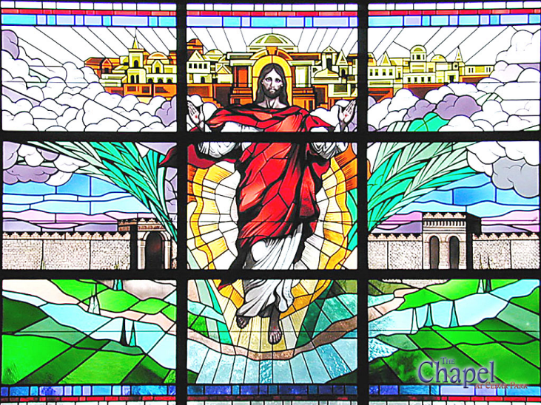*1 Then the angel showed me the river of the water of life, as clear as crystal, flowing from the throne of God and of the Lamb 2 down the middle of the great street of the city. On each side of the river stood the tree of life, bearing twelve crops of fruit, yielding its fruit every month. And the leaves of the tree are for the healing of the nations. 3 No longer will there be any curse.*

The Garden of Eden, and the original creation, has been restored. Eden had its trees and river. Everything was taken care of for the inhabitants. Thousands of years have passed between Genesis and Revelation. For all the changes that have taken place, we end up in remarkably similar places. *And the LORD God made all kinds of trees grow out of the ground-- trees that were pleasing to the eye and good for food. In the middle of the garden were the tree of life and the tree of the knowledge of good and evil. A river watering the garden flowed from Eden; from there it was separated into four headwaters*.[1]

The language of Revelation also mirrors the language of Ezekiel. The river that flows from the sanctuary during the Millennium had great feeding and therapeutic properties. *Fruit trees of all kinds will grow on both banks of the river. Their leaves will not wither, nor will their fruit fail. Every month they will bear, because the water from the sanctuary flows to them. Their fruit will serve for food and their leaves for healing*."[2]

The consistency of the language and description from Eden, Ezekiel’s Millennium, and John’s Revelation give a clue as to how important this is. This is significant and deserves consideration. The fact that we have similar pictures from Eden to Eternity reveals something of God’s intentions for people. Certainly who know what God started with and what he will end with. Seeing it on both ends might suggest to us what God wants even now.

Verse three is explicit that the curse has been lifted. The curse that is lifted is the curse that was upon the ground since the time of the expulsion from the Garden of Eden. "*Cursed is the ground because of you; through painful toil you will eat of it all the days of your life*.” With sin, the earth no longer produced blessings on its own. You should have seen parts of my garden this year. I created a fourth garden in three circular rows. I planted corn on each end. I bet I don’t get back as many kernels as we planted. The best use for that corn crop will be for humor. It is hard to take seriously a corn stalk that is two feet high trying to produce an ear of corn. With this crop I couldn’t even meet the biblical qualification of “he who has an ear let him hear….” If you are a better farmer than I am, then you had to work at it because the ground is cursed and it doesn’t give up a crop easily.

It would be a mistake to focus too much on the individual in their struggle to make a living. Notice that the text puts this change in national terms, not individual terms. It is not the farmer who struggles but the nation: *And the leaves of the tree are for the healing of the nations. 3 No longer will there be any curse.*

Again and again, Revelation wants us to see the nations. Revelation sees kings and kingdoms, ethnic groups and nations in need of healing. It seems clear to me that the healing is for nations not just individuals. That is one of the key narratives of Revelation. The kingdoms of man are giving way to the kingdom of God. The four kingdoms prophesied by Daniel got sick and seriously off track. We are feeling that in America right now. In this last election 45% of the voters in Washington State said they never went to church. Is it any wonder they voted for R-90?

We can look at the increasing legalization of hard drugs like they just did in Oregon. Hard drugs are now legal but plastic straws are not. That state basically said they are willing for people to kill themselves and we will not interfere. The new normal is that people can bring any manner of harm to themselves and indirectly to their families and we will not interfere out of respect for their “freedom.” Of course, the same does not apply to facemasks but that is a different matter.

When the nations are healed, as described here in Revelation, the fruit of the trees is available every month, year round. The land becomes productive on its own once again. No longer does man have to overcome the curse upon the ground by the sweat of his brow. God provides in quite a direct way.

I think you can see the big picture when you compare the Garden of Eden to Revelation 22. But does this pattern suggest anything for right now.

First, I think it shows that God is interested in his people doing well. They will in the future and they can do well in the interim also.

The river suggests this lifting of the curse is not primarily physical but something from the Holy Spirit. What the angel showed John was “… *the river of the water of life, as clear as crystal, flowing from the throne of God and of the Lamb 2 down the middle of the great street of the city.”* We read about the water of life in the last chapter and made the connection to what Jesus said *“Whoever believes in me, as the Scripture has said, streams of living water will flow from within him." By this he meant the Spirit, whom those who believed in him were later to receive. Up to that time the Spirit had not been given, since Jesus had not yet been glorified.*[3]

The Spirit works in and through us to produce blessings. God’s way is a way of blessing while the other way is the way of the curse. Salvation is not the same as money or finances, but the two should not be separated too much either. The rain falls on the just and the unjust, but that should be modified by the idea of God’s blessing. At the end, in Revelation 22, the culmination of all things earthly is with God providing all that is needed through his Holy Spirit. It all has a decidedly earthly ring to it.

In the beginning after Eden, work was the means for overcoming the curse. Even today, those who love work have a lot better chance of overcoming the curse. Those who hate work will see the curse up close and personal. But a nation that does not love God and have a place for him will find there is no limit to how low the economy can go. Nations need healing.

*The throne of God and of the Lamb will be in the city, and his servants will serve him. 4 They will see his face, and his name will be on their foreheads. 5 There will be no more night. They will not need the light of a lamp or the light of the sun, for the Lord God will give them light. And they will reign for ever and ever. 6 The angel said to me, "These words are trustworthy and true. The Lord, the God of the spirits of the prophets, sent his angel to show his servants the things that must soon take place." 7 "Behold, I am coming soon! Blessed is he who keeps the words of the prophecy in this book." 8 I, John, am the one who heard and saw these things. And when I had heard and seen them, I fell down to worship at the feet of the angel who had been showing them to me. 9 But he said to me, "Do not do it! I am a fellow servant with you and with your brothers the prophets and of all who keep the words of this book. Worship God!" 10 Then he told me, "Do not seal up the words of the prophecy of this book, because the time is near. 11 Let him who does wrong continue to do wrong; let him who is vile continue to be vile; let him who does right continue to do right; and let him who is holy continue to be holy." 12 "Behold, I am coming soon! My reward is with me, and I will give to everyone according to what he has done.*

The coming of the Lord is sufficiently near that it is not necessary to seal up the words. Leave them plainly exposed because everyone will need the encouragement that comes from reading this book. The final recompense is at hand. Everyone will get what they deserve. All accounts will be settled for good and ill.

*13 I am the Alpha and the Omega, the First and the Last, the Beginning and the End. 14 "Blessed are those who wash their robes, that they may have the right to the tree of life and may go through the gates into the city. 15 Outside are the dogs, those who practice magic arts, the sexually immoral, the murderers, the idolaters and everyone who loves and practices falsehood. 16 "I, Jesus, have sent my angel to give you this testimony for the churches. I am the Root and the Offspring of David, and the bright Morning Star*."

That Jesus so plainly calls himself Alpha and the Omega is an important clue to who he really is. He is not merely the mortal Son of God. In chapter one, the Alpha and the Omega called himself the one "who is, and who was, and who is to come, the Almighty."[4] From this we can conclude that Jesus is eternal. He had no beginning and he will have no end. Further he is the Almighty, a name reserved for God alone. Jehovah’s Witnesses must choke on this verse.

Not everyone may enter into the city of God and eat of the tree. They must have clean robes. They must not be involved in the occult. We know from Acts that Ephesus was a city filled with magic arts. The church also had problems rooting this out. In Timothy, Paul warns against women returning to following Satan, particularly through the vehicle of what they had been saying.[5] The term for busybodies, according to Thayer, has implications of the magic arts. Other sins are mentioned, not because they are the only ones but because of issues relating to those sins in Asia Minor.

*17 The Spirit and the bride say, "Come!" And let him who hears say, "Come!" Whoever is thirsty, let him come; and whoever wishes, let him take the free gift of the water of life. 18 I warn everyone who hears the words of the prophecy of this book: If anyone adds anything to them, God will add to him the plagues described in this book. 19 And if anyone takes words away from this book of prophecy, God will take away from him his share in the tree of life and in the holy city, which are described in this book. 20 He who testifies to these things says, "Yes, I am coming soon." Amen. Come, Lord Jesus. 21 The grace of the Lord Jesus be with God's people. Amen*.

1. Genesis 2:9-10
2. Ezekiel 47:12.
3. John 7:37-39
4. Revelation 1:8.
5. 1 Tim 5:13-15 “Besides, they get into the habit of being idle and going about from house to house. And not only do they become idlers, but also gossips and busybodies, saying things they ought not to. So I counsel younger widows to marry, to have children, to manage their homes and to give the enemy no opportunity for slander. Some have in fact already turned away to follow Satan.